# I. Databases

## What is database

* Organize collection of data
* Two types of databases:
  + Operational database - collect, modify and maintain data on daily basis.
  + Analytical database - mainly for historical and time-dependant data
* Based on two mathematical theories
  + Set theory
  + First-order predicate

## Relational database Model

Based on the concept of  “relation”:

* **Relation/Table:** a relation (table) is a set of tuples
* **Tuple/Row:** a tuple is an individual row in a relation. Each tuple represents a single record
* **Attribute/Column:** An attribute is a named column of a relation
* **Degree:** The degree of a relation is the number of attributes it contains
* **Cardinality:** Cardinality refers to the number of tuples in a relation - колко реда има таблицата ни
* **Relational Algebra:** Procedural query language for the relational model

**Domain:**

* Refers to the set of allowable values that a column (attribute) can contain.
* It’s the type of data that can be stored in a certain column
* Example: a domain of a `salary` column could be all real numbers, or the domain of a `gender` column could be ‘male’, ’female’, ’prefer not to say’

**Relation:**

* Table in a relational database
* Set of tuples that have the same attributes
* A relation is defined by its name and the set of attributes it contains

## Relational database Schema

* Describes the structure of a database in a formal way
* Provides definitions for tables, fields, relationships, views, indexes, packages, procedures, functions, queues, triggers, sequences, synonyms and other objects
* Defines constraints over the database objects
* In many cases normalization is a key requirement for a database schema

### Data normalization

Нормализация на базите данни

<https://bg.myservername.com/database-normalization-tutorial>

* What is normalizaton
* Normal forms
  + **1NF** - **Used to eliminate repeating groups**

First normal form means the following conditions are met:

* Eliminate repeating groups in individual tables
* Create a separate table for each set of related repeated data
* Identify each set of related data with Primary key

Do not use multiple fields in a single table to store similar data:

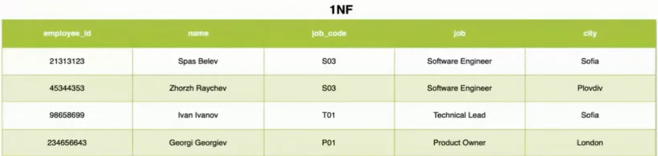

* **2NF** - **Used to eliminate redundant data**

Second normal form means the following conditions are met:

* Create separate tables for sets of values that apply to multiple records
* Relate these tables with a foreign key

Records should not depend on anything other than a table’s Primary key:

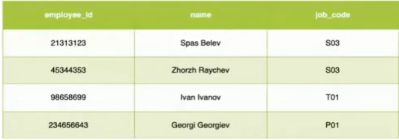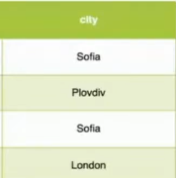

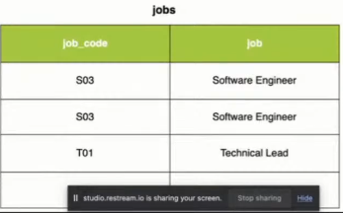

* **3NF** - **Used to eliminate columns that are not dependent on the key of the table**

Third normal form checks for **transitive dependencies**:

* Eliminate fields that do not depend on the key

Records that are not a part of the record’s key do not belong in the table

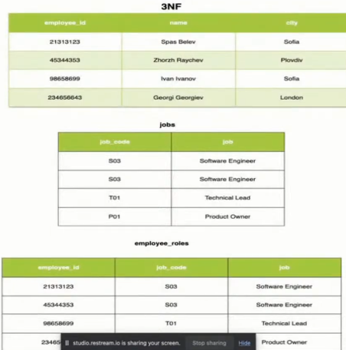

* 4NF - Isolate Independent Multiple Relationships
* 5NF - Isolate semantically related Multiple Relationships

### Как работи отдолу една RDBMS

Writer

Reader

Archiver

Vacuum

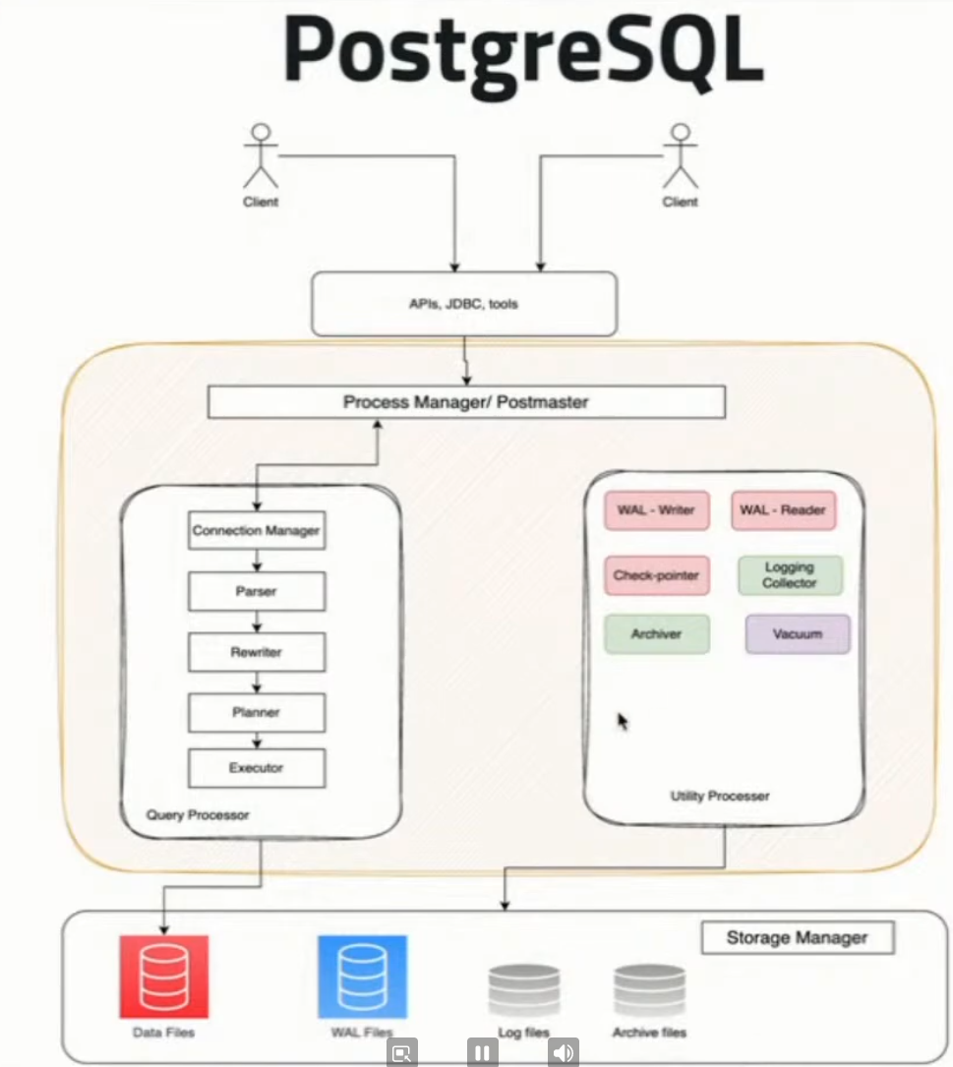

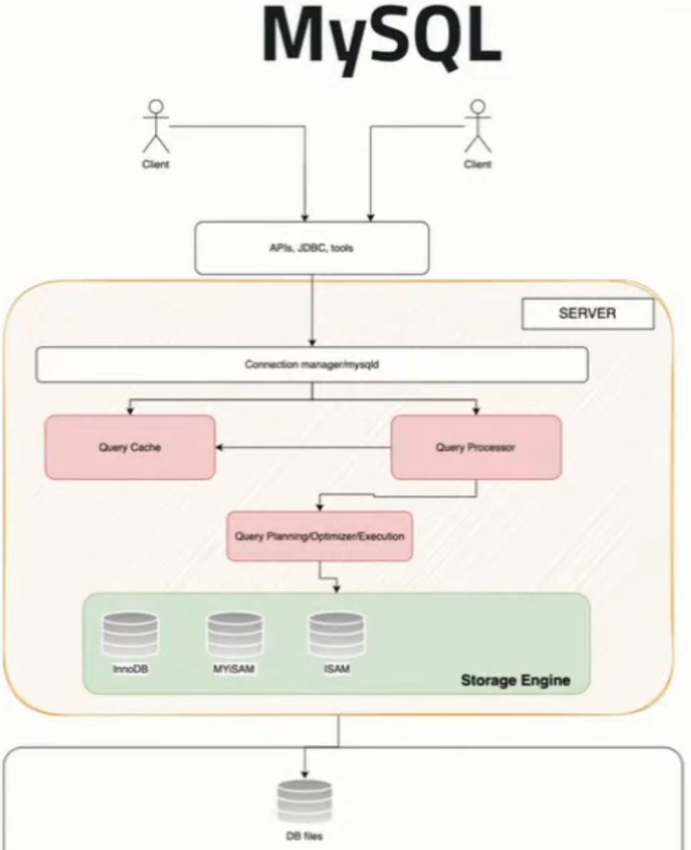

### Indexes

* Improve the speed of data retrieval operations on a database table at the cost of additional writes and storage space
* Indexes are used to quickly locate data without having to search every row
* Indexes can be created using one or more columns of a database table.
* The **primary key is called also clustered index**. All other indexes are called non-clustered indexes.

Key points about indexes:

* **Index Types:** There are several types of indexes, such as B-tree, bitmap, and hash indexes, each suited to particular types of queries
* **Composite index:** An index with 2 or more columns at the same time
* **Index Key:** The column(s) on which the index is created
* **Primary key:** A type of constraint used in a table to uniquely identify each record in this table. It automatically creates an index known as a clustered index.
* **Unique index:** It ensures data present in the column is unique. It happens automatically. It allows one null value for a column!

### Indices и балансирано бинарно дърво

* Structures associated with a table or view that speeds retrieval of rows
  + Usually implemented as **B-trees**
* Indices can be built-in the table (**clustered**) or stored externally (**non-clustered**)
* Adding and deleting records in indexed tables is slower!
  + Indices should be used for big tables only (e.g. 50 000 rows)

Когато имаме много на брой данни, в даден момент се налага преиндексиране на базата данни, за да се постигне балансирано бинарно дърво.

Небалансираното дърво забавя много операциите.



#### Clustered Indices

* **Clustered index(primary key) determine the order of data**
  + Very useful for fast execution of **WHERE**, **ORDER BY** and **GROUP BY** clauses
* Maximum 1 clustered index per table
  + If a table has no clustered index, its data rows are stored in an **unordered structure** (heap)

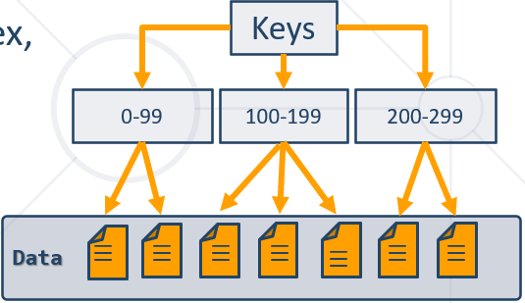

#### Non-Clustered Indices

* Useful for fast retrieving a **single record** or a **range** of records
  + Each **key value entry** has a pointer to the data row that contains the key value
* Maintained in a separate structure in the DB

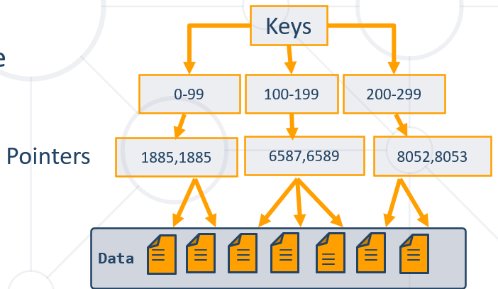

Синтаксис на индекс

**CREATE INDEX**

ix_users_first_name_last_name

**ON** `users`(`first_name`, `last_name`);

### Stored procedures

* Group of pre-compiled SQL statements that are stored in the database
* Can be invoked (or called) by:
  + User application programs
  + Triggers
  + Other stores procedures from within the database
* Encapsulate logic for data transformation, data validation, and business-specific logic

Benefits of using stored procedures:

* Performance: Because stored procedures are compiled and stored in the database, they tend to be more efficient and faster.
* Network traffic: using stored procedures can reduce network traffic between clients and servers
* Security: stored procedures provide an additional layer of security. You can grant users the permission to execute a stored procedure without giving them access to the underlying tables
* Code reuse and encapsulation: Logic created in stored procedures can be reused across multiple programs

In some cases, better in the Java code to be the logic and to have more network traffic!!!

### Functions

* Precompiled SQL commands that are used to perform a specific task or operation and return a value
* Built-in(aggregate, Scalar, Date, and many more)   or  user-defined
* Много рядко може да се наложи да си правим наша си функция. В повечето случаи вградените функции са достатъчни

## Design process

* Requirement Analysis: understand what the database will be used for, by who and what data it will store - ще пишем или ще четем повече от базата, и други подобни въпроси
* Conceptual Database Design: Identify the high-level entities and relationships among them. An E/R is often created.
* Logical Database Desing: Translate the conceptual model into a logical model, which is a more detailed and precise representation of the data
* Physical Database Design
* Database Implementation

### Entities

**Entity** - a definable thing - such as a person, object, concept or event - that can have data stored about it.

**Strong entity** - има си всички атрибути и е самодостатъчно/самоопределящо се. И няма нужда от foreign keys.

**Weak entity** - не може да се самоопредели от атрибутите си какво е точно

**Associative entity** - associates entities (or elements) within an entity set

**Entity set:** - same as entity type, but defined at a particular point in time, such as students enrolled in a class on the first day

### Relationship

* How entities act upon each other or are associated with each other - One to Many, Many to One, Many to Many, One to One, etc.
* Relationships are typically shown as **diamonds** (on the ER diagrams)   *or*   labels directly on the **connecting lines**

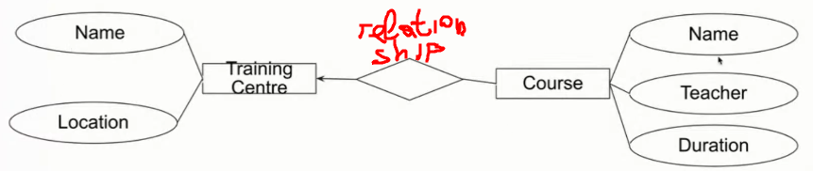

### Attribute

* Attributes are categorized as simple, composite, derived, as well as single-value or multi-value:
  + Simple: attribute value is **atomic** and can’t be further divided
  + Composite: Sub-attributes spring from an attribute
  + Derived: Attribute is calculated or otherwise derived from another attribute, such as age from a birthdate

### Cardinality

* Defines the numerical attributes of the relationship between two entities or entity sets
* The three main cardinal relationships are one-to-one, one-to-many, and many-to-many

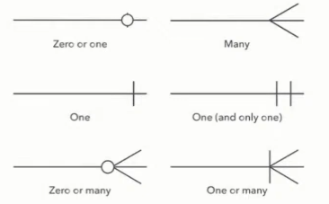

### Tools for creating E\R or similar database diagrams (Data Modelling Tools):

* Lucidchart
* Microsoft Visio
* Draw.io
* MySQL Workbench
* ER/Studio
* <https://dbdiagram.io/home>
* IntelliJ Idea Ultimate
* pgAdmin
* <https://dbeaver.io/>

# II. MySQL Relational Database

Езикът за релационни база данни е един с леки диалекти – просто мениджмънт системата за управление на данни е различна – Oracle, MariaDB, MySQL, PostgreSQL, etc.

<https://www.w3schools.com/sql/sql_where.asp>

За Judge на СофтУни – ако не е зададено другояче, базата данни /схемата не я цитираме като подаваме решенията си в Judge.

## 0. Някои basic неща

MySQL е case insensitive – команди можем да пишем както с големи, така и с малки букви

Слагаме коментари с: # или /*…. */

Ctrl + / - слага в коментар по друг начин

Полета/обекти винаги ограждаме с тилда кавички **`**….**`** като по този начин escape-ваме запазени думи в SQL

Ctlr + D – добавяме един ред като горния ред

Числата въвеждаме без скоби

Текстовете ограждаме с единични обикновени скоби ‘….’

За пари ползваме DECIMAL вместо DOUBLE

NULL

TRUE

FALSE

= присвоява стойност – ДА и знак за сравнение - ДА

SET e_count **:=** присвояване

**!= или <>** значат и двете различно, работи само за числови стойности. Иначе използваме IS NULL / IS NOT NULL

>= по-голямо

<= по-малко

Като кликнем колоните на таблица, то името на колоната се нанася в SQL заявката – да не си играем да пишем ръчно името на колоната

Като цяло, при базите данни, гледаме 90% предварително, и след това пишем заявките.

Ctrl + R – reverse Engineering

Ctrl + Space – Auto suggest

Реално не можем да дебъгваме в MySQL дадена функция/процедура/или какво и да е

+

-

*

/ - обикновено **дробно** делене

% или mod() модулно делене не работи по нормален начин

## 1. Introduction to MySQL

### 1.0. General info

* A database is an **organized** collection of **related** information
  + It imposes **rules** on the contained data
  + Access to data is usually provided by a "**system**" (DBMS) **database** **management**
  + Relational storage first proposed by Edgar Codd in 1970
* **R**elational **D**ata **B**ase **M**anagement **S**ystem
  + Database **management**
  + It **parses requests** from the user and takes the **appropriate** action
  + The user **doesn't have direct access** to the stored data
  + Data is presented by **relations** – collection of tables related by **common fields**
  + MS SQL Server, DB2, Oracle and MySQL

### 1.1. Database Engine Flow

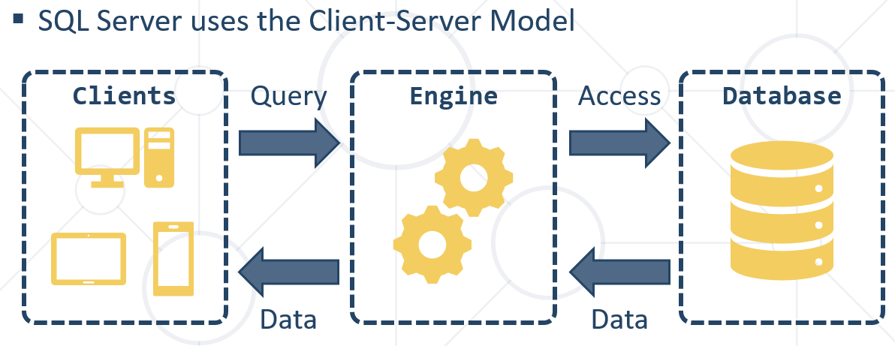

**Client-Server Model**



### 1.2. Structured Query Language = SQL

* + Queries
  + Clauses
  + Expressions
  + Predicates
  + Statements

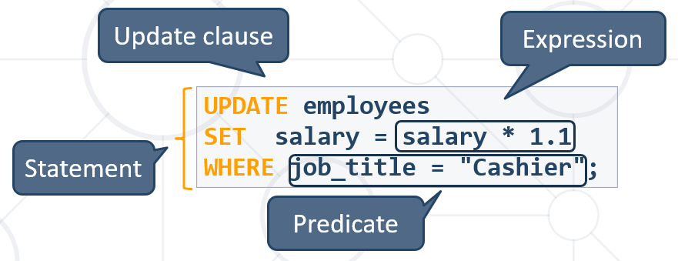

### 1.3. DDL, DML, DCL, TCL

Logically divided in four sections

* + **Data Definition Language**– describe the structure of our data = **DDL**
  + **Data Manipulation Language** – store and retrieve data = **DML**

**CRUD** is part of **DML** – Create, Read, Update, Delete

* + **Data Control Language** – define who can access the data = **DCL**
  + **Transaction Control Language** – bundle operations and allow rollback = **TCL**

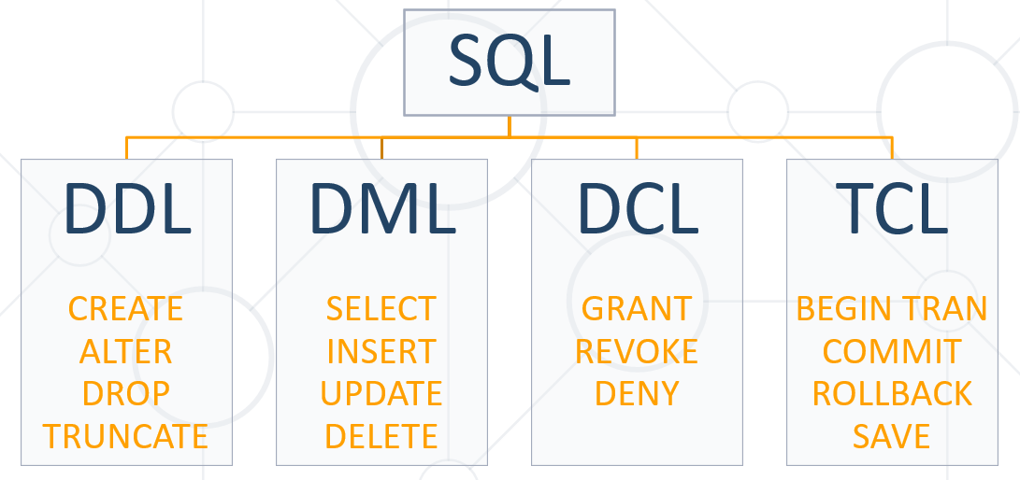

### 1.3. DQL

**Data query language** (DQL) is part of the base grouping of SQL sub-languages. These sub-languages are mainly categorized into:

* a data query language (**DQL**),
* a data definition language (DDL),
* a data manipulation language (DML).
* a data control language (DCL),
* Transaction control language (TCL)

DQL statements are used for performing queries on the data within schema objects. The purpose of DQL commands is to get the schema relation based on the query passed to it.

Although often considered part of DML, the SQL [SELECT](https://en.wikipedia.org/wiki/Select_(SQL)) statement is strictly speaking an example of DQL. When adding FROM or WHERE data manipulators to the SELECT statement the statement is then considered part of the DML.

### 1.4. MySQL Server Architecture

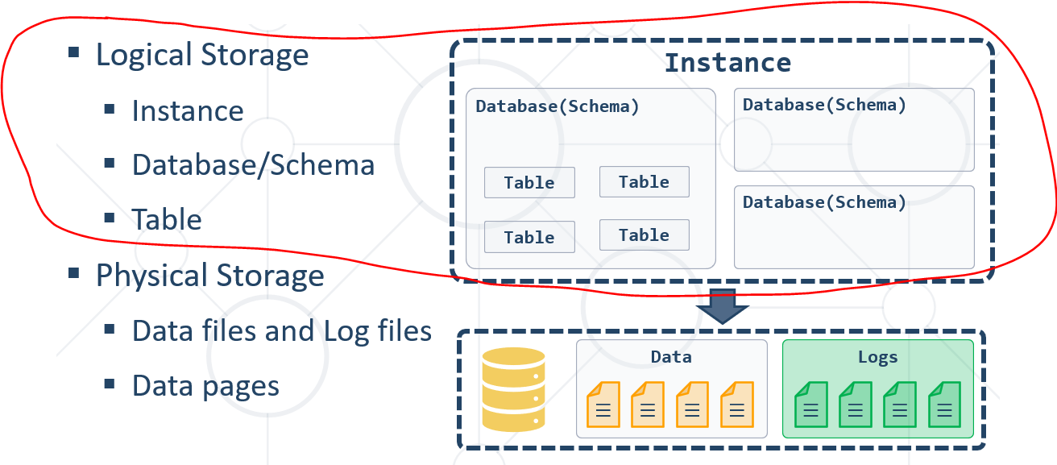

### 1.5. Database Table Elements

* The table is the main **building block** of any database
* Each **row** is called a **record** or **entity**
* Columns (**fields**) define the **type** of data they contain

### 1.6. Table Relationships

* We split the data and introduce **relationships** between the tables to **avoid** repeating information
* Connection via **Foreign Key** in one table pointing to the **Primary** **Key** in another

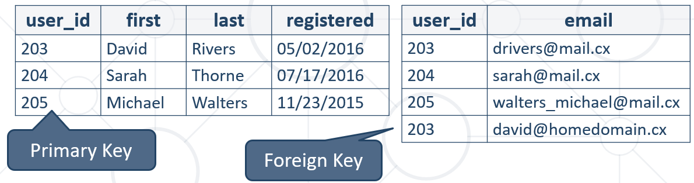

### 1.7. Programmability

#### 1.7.1. Indices

* Indices make data lookup faster
  + Clustered – bound to the **primary key**, physically sorts data
  + Non-Clustered – can be **any field**, references the primary index
* Structured as an **ordered tree**

Бинарно дърво – за по-бързо търсене в базата данни

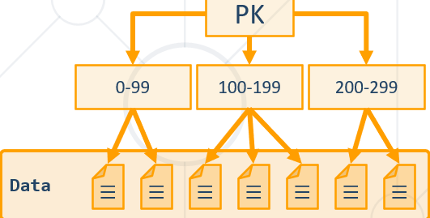

#### 1.7.2. Views

* Views are **prepared queries** for displaying **sections** of our data

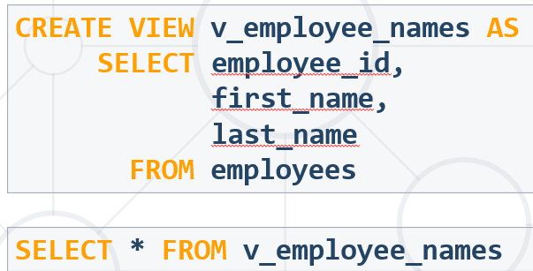

* Evaluated at **run time** – they do not increase performance

#### 1.7.3. Procedures, Functions and Triggers

A database can further be customized with reusable code

* **Procedures** – carry out a predetermined **action**
  + E.g. get all employees with salary above 35000
* **Functions** – receive **parameters** and return a **result**
  + E.g. get the age of a person using their birthdate and current date
* **Triggers** – **watch** for activity in the database and **react** to it
  + E.g. when a record is deleted, write it to an archive

### 1.8. Data Types in MySQL Server

#### 1.8.1. Numeric Data Types

* Numeric data types have certain range
* Their range can be changed if they are:
  + **Signed** - represent numbers both in the positive **and** negative ranges
  + **Unsigned -** represent numbers **only** in the positive range
* E.g. signed and unsigned INT:

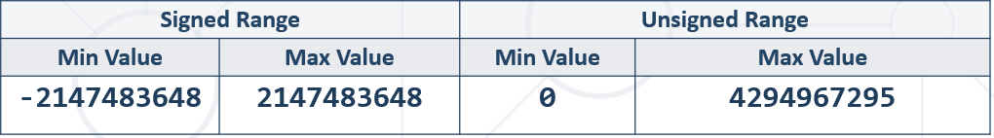

* **INT** [(*M*)] [UNSIGNED] INT(10) – число с 10 цифри
  + **T**INYINT, **S**MALLINT, **M**EDIUMINT, **B**IGINT
* **DOUBLE** [(*M, D*)] [UNSIGNED]



* + E.g. DOUBLE(5, 2) – 999.99 – общо са 5 цифри, като след десетичната запетая са 2 цифри
* **DECIMAL** [(*M, D* )] [UNSIGNED] [**ZEROFILL**] – слага нули отпред ако е нужно

DECIMAL за по-голяма точност

M – общо брой цифри

D- от които след десетичната запетая

#### 1.8.2 String Types

String column definitions include attributes that specify the **character set** or **collation**.

* **CHARACTER SET** (Encoding) - Determines the storage of each character (single or multiple bytes)

E.g. utf8, ucs2

* **CHARACTER COLLATION** – rules for encoding comparison - Determines the sorting order and case-sensitivity

E.g. latin1_general_cs, Traditional_Spanish_ci_ai etc

* **Set and collation** can be defined at the database, table or column level

**Non-unicode (just English, western languages)**

* **CHAR** (M) - up to 255 characters
  + fixed-length character type (example CHAR(30) или CHAR(1) )
* **VARCHAR**(M) **–** up to 65 535 characters
  + Variable max size
* **TEXT** – up to 65 535 characters
  + TINYTEXT, MEDIUMTEXT, LONGTEXT
* **BLOB - B**inary **L**arge **Ob**ject [(M)] - 65 535 (216 − 1) characters – когато не пазим адреса/пътя към снимката, а пазим битовата символна версия от 1000+ символа на самата снимка
  + TINYBLOB, MEDIUMBLOB, LONGBLOB

TINYBLOB : L < 2^8 = 256 Bytes

BLOB : L < 2^16 = 65,536 Bytes

MEDIUMBLOB : L < 2^24 = 16,777,216 Bytes

LONGBLOB : L < 2^32 = 4,294,967,296 Bytes

fieldName Blob(size in bytes) -

The short answer **is**: **VARCHAR is** variable length, while **CHAR is** fixed length. **CHAR is** a fixed length string data type, so any remaining space **in the** field **is** padded with blanks. **CHAR** takes up 1 byte per character. ... **VARCHAR is** a variable length string data type, so it holds only the characters you assign to it.

**Двойно повече място за Unicode (all languages worldwide)** - Supports many client computers that are running different locales.

nchar/nvarchar - произлиза от national

|  |  |  |  |  |
| --- | --- | --- | --- | --- |
|  | **char** | **nchar** | **varchar** | **nvarchar** |
| Character Data Type | Non-Unicode fixed-length | Unicode fixed-length can store both non-Unicode and Unicode characters (i.e. Japanese, Korean etc.) | Non-Unicode variable length | Unicode variable length can store both non-Unicode and Unicode characters (i.e. Japanese, Korean etc.) |
| Maximum Length | up to 8,000 characters | up to 4,000 characters | up to 8,000 characters | up to 4,000 characters |
| Character Size | takes up 1 byte per character | takes up 2 bytes per Unicode/Non-Unicode character | takes up 1 byte per character | takes up 2 bytes per Unicode/Non-Unicode character |
| Storage Size | n bytes | 2 times n bytes | Actual Length (in bytes) | 2 times Actual Length (in bytes) |
| Usage | use when data length is constant or fixed length columns | use only if you need Unicode support such as the Japanese Kanji or Korean Hangul characters due to storage overhead | used when data length is variable or variable length columns and if actual data is always way less than capacity | use only if you need Unicode support such as the Japanese Kanji or Korean Hangul characters due to storage overhead |
|  |  |  | query that uses a varchar parameter does an index seek due to column collation sets | query that uses a nvarchar parameter does an index scan due to column collation sets |

#### 1.8.3. Date Types

* **DATE -** for values with a date part but **no time part -** 'YYYY-MM-DD' or 'YY-MM-DD'
* **TIME -** for values with time but **no date part –** ’hh: mm: ss’
* **DATETIME -** values that contain both date **and** time parts - ‘YYYY-MM-DD hh: mm: ss’
* **TIMESTAMP -** both date **and** time parts
* MySQL retrieves values for a given date type in a **standard output format**

E.g. as a string in either 'YYYY-MM-DD' or 'YY-MM-DD'

**ВАЖНО**

Когато сравняваме дата DATE с DATESTAMP, изречението „hired after 1/1/1999“ го тълкуваме

WHERE e.`hire_date` >= '1999-01-02'

защото имаме DATESTAMP 1999-12-12 **01:26**:00.000000

#### 1.8.4. Boolean Types

`gender` **BOOLEAN**;

CREATE TABLE `people`(

`id` INT NOT NULL UNIQUE AUTO_INCREMENT PRIMARY KEY,

`name` VARCHAR(200) NOT NULL,

`picture` MEDIUMBLOB,

`height` DOUBLE(5,2),

`weight` DOUBLE(5,2),

`gender` CHAR(1) NOT NULL,

`birthdate` DATE NOT NULL,

`biography` LONGTEXT

);

### 1.9. **DDL – Data Definition Language** - Database Modelling – using GUI or via basic SQL queries

**Да даваме Refresh от време на време**

* **Working with IDEs – MySQL Workbench** Database ManagementSystem - we can use GUI Clients to **create** and **customize** tables
* Enables us:
  + To **create** a new database
  + To create **objects in the database** (tables, stored procedures, relationships and others)
  + To **change** the properties of objects
  + To **enter records** into the tables

#### 1.9.0. Creating a New Database

* Select **Create new schema** from the command menu

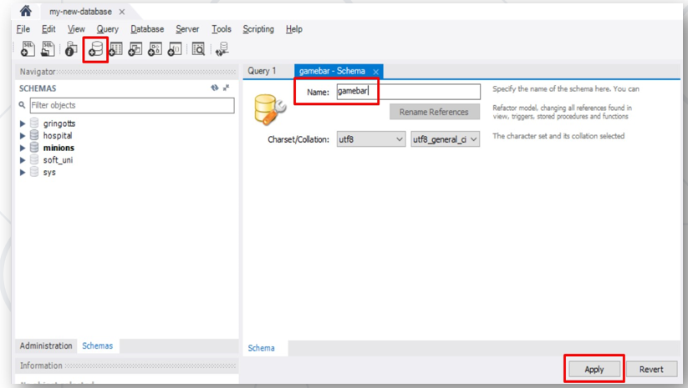

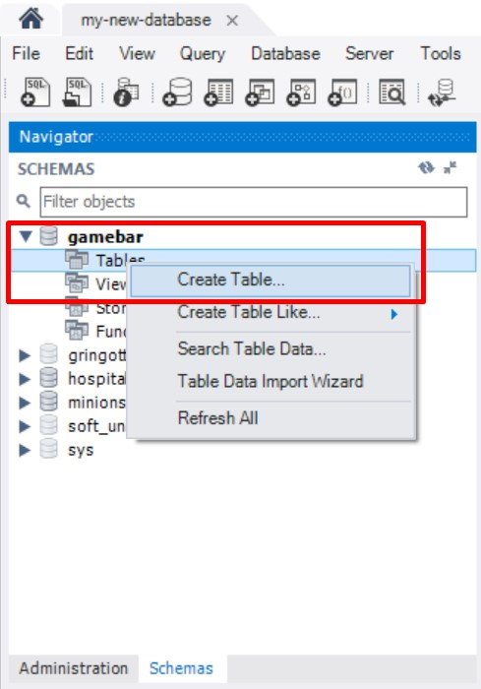

* **A Primary Key is used to uniquely identify and index records**

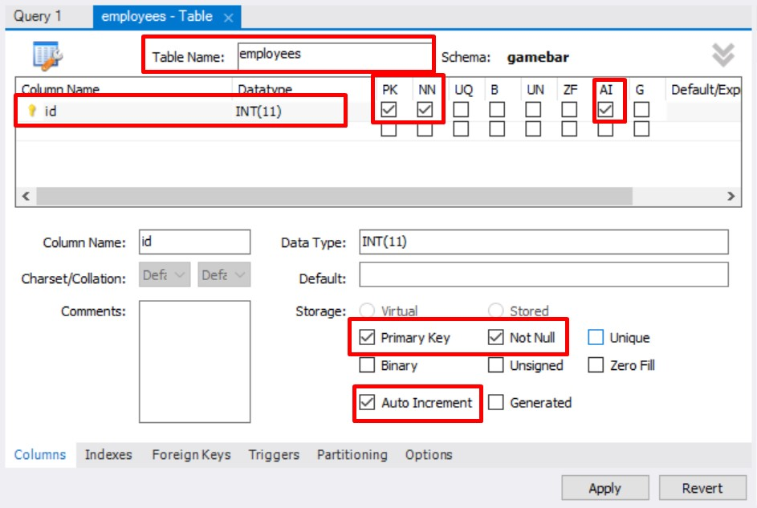

#### 1.9.1. Foreign keys

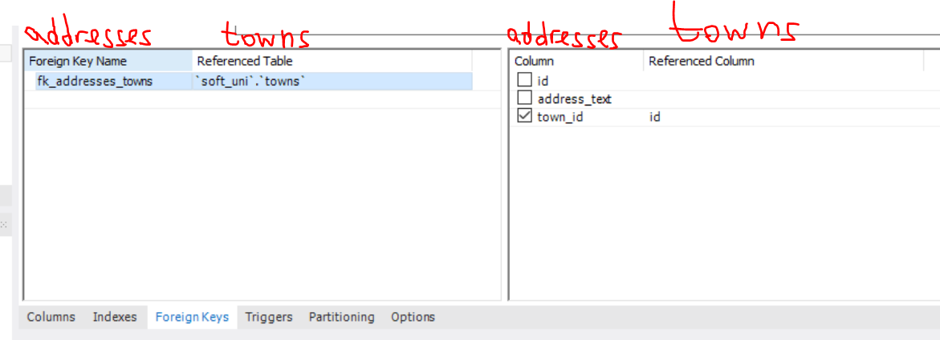

* **Adding foreign keys**

A FOREIGN KEY is a field (or collection of fields) in one table, that refers to the PRIMARY KEY in another table.

**The table with the foreign key is called the child table, and the table with the primary key is called the referenced or parent table.**

Конвенция при изписване на foreign key поле: fk_fromMinions_toTowns

В minions е чуждия ключ, а в Towns е primary ключ.

ВАЖНО: когато създаваме foreign keys, първо трябва да създадем таблицата, от която foreign key ще взема данни.

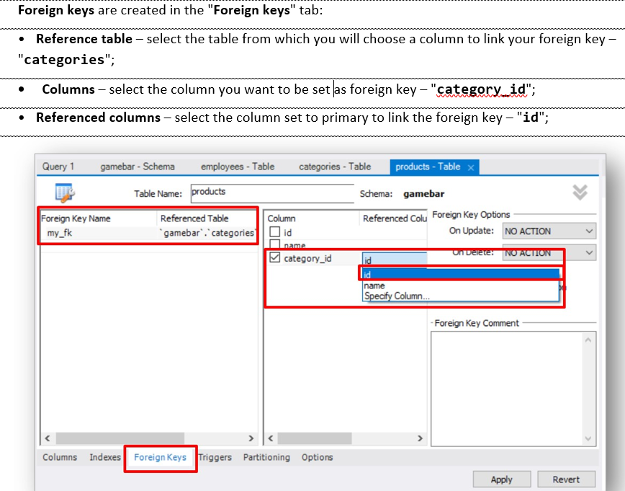

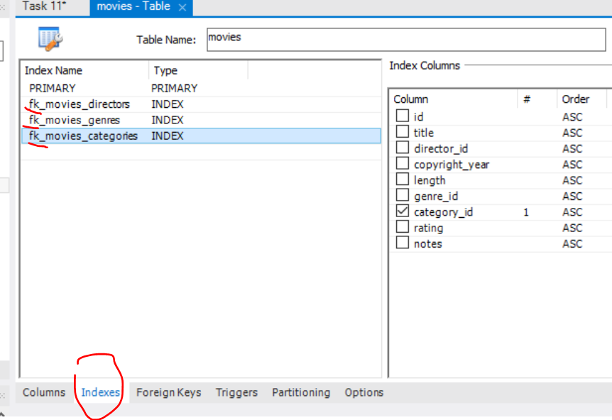

CREATE TABLE `Orders` (  
    `OrderID` int NOT NULL,  
    `OrderNumber` int NOT NULL,  
    `PersonID` int,  
    PRIMARY KEY (`OrderID`),

CONSTRAINT `fk_source_target`  
    FOREIGN KEY `Orders`(`PersonID`)

REFERENCES `Persons`(`PersonID`)  
);

SQL FOREIGN KEY on ALTER TABLE

ALTER TABLE `products`

ADD CONSTRAINT `fk_products_categories`

FOREIGN KEY `products`(`category_id`)

REFERENCES `categories`(`id`);

ALTER TABLE `minions`.`minions`

ADD CONSTRAINT `fk_minions_towns`

FOREIGN KEY (`town_id`)

REFERENCES `minions`.`towns` (`id`);

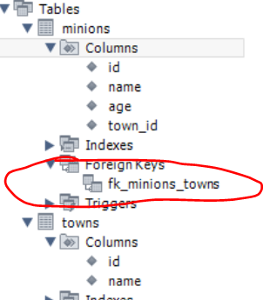

#### 1.9.2. Where to run our SQL queries

Working with basic SQL queries

* We communicate with the database engine using SQL
* Queries provide greater **control** and **flexibility**

**Queries are written in the "Query" tab.**

**Database creation**

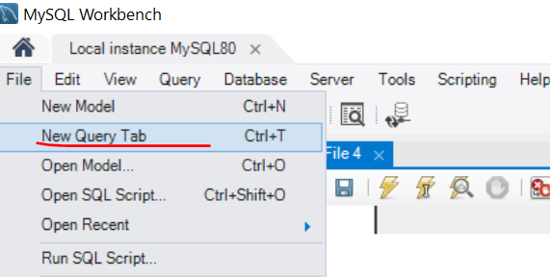

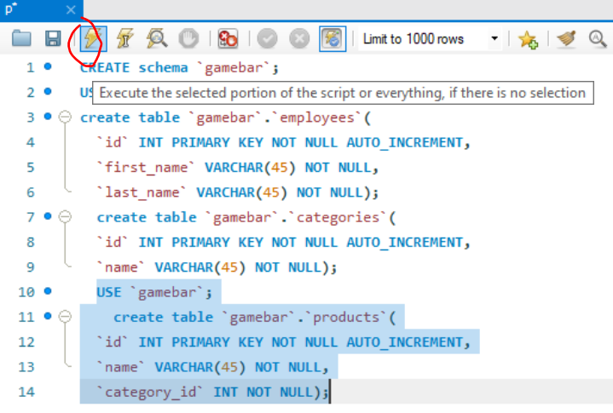

**CREATE DATABASE** `gamebar`; или **CREATE SCHEMA** `gamebar`;

Ако искаме да отворим съществуващ SQL script, то правилния начин и е цъкнем **File -> Open SQL script**

#### 1.9.3. Table Creation in SQL:

В работната част gamebar, създай таблица employees – за графично, виж скрийншота по-горе

The command **USE** – ако имаме отворени няколко база данни, да знаем с коя работим

**USE** `gamebar`

**CREATE TABLE** `gamebar`.`employees` (

`id` **INT NOT NULL AUTO_INCREMENT**,

`name` **VARCHAR(45) NOT NULL**,

**PRIMARY KEY** (`id`));

Или

**create table** `gamebar`.`categories`(

`id` **INT PRIMARY KEY NOT NULL AUTO_INCREMENT**,

`name` **VARCHAR(45) NOT NULL**);

**Sugar syntaxis for AUTO_INCREMENT** – задаване на първоначална стойност, от която да започне да инкрементира с единица:

CREATE TABLE models (

`model_id` INT AUTO_INCREMENT UNIQUE NOT NULL,

`name` VARCHAR(20) NOT NULL,

`manufacturer_id` INT NOT NULL

) **AUTO_INCREMENT** = 101; //започни от 101 като първи запис

#### 1.9.4. Add records in SQL:

##### Option 1 – през графични interface

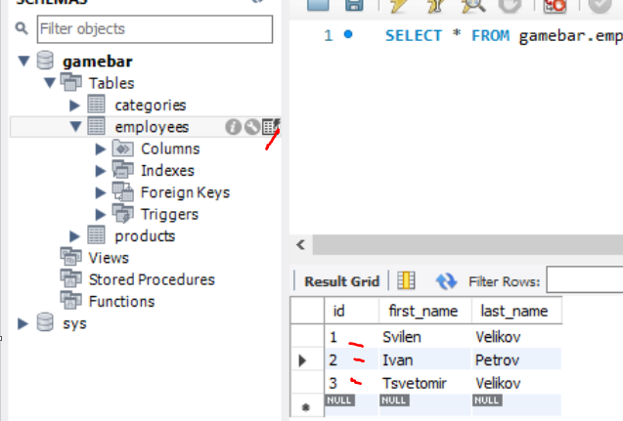

##### Опция 2 – с SQL заявка и hardcore-нати стойности

**INSERT INTO** `gamebar`.`employees` (`id`, `first_name`, `last_name`) **VALUES** ('1', 'Svilen', 'Velikov');

**INSERT INTO** `gamebar`.`employees` (`id`, `first_name`, `last_name`) **VALUES** ('2', 'Ivan', 'Petrov');

**INSERT INTO** `gamebar`.`employees` (`id`, `first_name`, `last_name`) **VALUES** ('3', 'Tsvetomir', 'Velikov');

**Или така:**

INSERT INTO `towns` (`id`, `name`)

VALUES

(1, 'Sofia'),

(2, 'Plovdiv'),

(3, 'Varna');

**Или ако вкарваме всичко:**

INSERT INTO `towns` пропускаме скобите или слагаме само празни скоби

VALUES

(1, 'Sofia'),

(2, 'Plovdiv'),

(3, 'Varna');

##### Опция 3 – с SQL заявка, без VALUES и с функция за определяне/за автоматично попълване

**Пример 1**

**INSERT INTO** cards(card_number, card_status, bank_account_id)

**(**без тези скоби в judge

**SELECT** REVERSE(full_name), 'Active', id

FROM clients

WHERE id>=191 AND id<=200

**);** без тези скоби в judge

**Пример 2**

INSERT INTO `coaches`(`first_name`, `last_name`, `salary`, `coach_level`)

SELECT `first_name`, `last_name`, `salary`,

CHAR_LENGTH(`first_name`)

FROM `players`

WHERE `age` >= 45;

**Пример 3**

INSERT INTO cards(card_status, card_number, bank_account_id)

( без тези скоби в judge

SELECT (

CASE

WHEN id BETWEEN 191 AND 199 THEN 'Active'

WHEN id BETWEEN 200 AND 299 THEN 'Inactive'

WHEN id BETWEEN 300 AND 500 THEN 'Deleted'

END

) AS customs_status, REVERSE(full_name), id

FROM clients

); без тези скоби в judge

#### 1.9.5. Erasing data in SQL:

* Deleting structures is called **dropping**
  + You can drop **keys**, **constraints**, **tables** and entire **databases**
* Deleting all data in a table is called **truncating**
* Both of these actions **cannot be undone** – use with caution!
* **To delete all the entries in a table, but keep the table structure**

**TRUNCATE TABLE** employees**;**

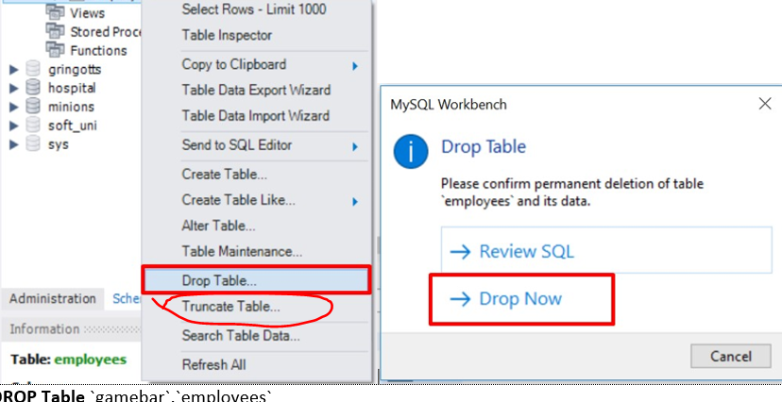

* **Dropping table - delete data and structure**

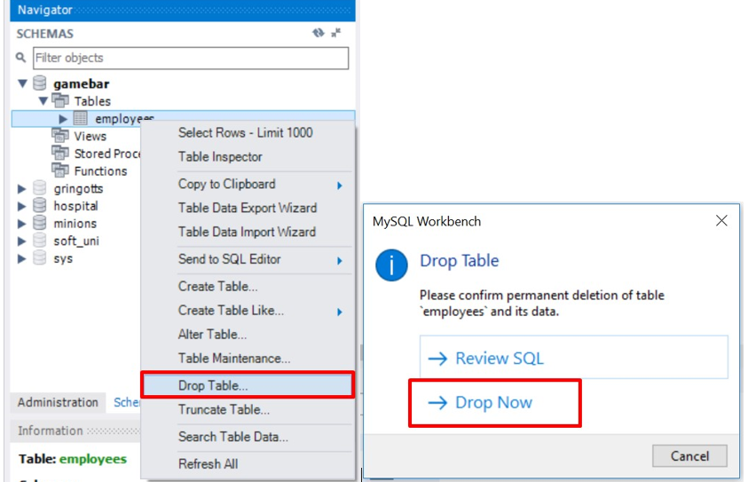

**DROP** **Table** `gamebar`.`employees`

* **Dropping the entire Database**

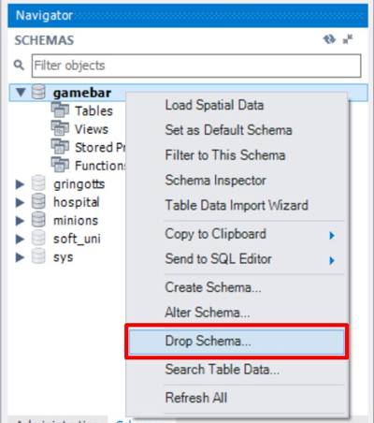

**DROP DATABASE** `gamebar`

* **To remove a constraining rule from a column**
  + Primary keys, value constraints and unique fields

**ALTER TABLE** employess **DROP CONSTRAINT** pk_id**;**

* **To remove DEFAULT value (**if not specified, revert to NULL**)**

**ALTER TABLE** employess

**ALTER COLUMN** clients

**DROP DEFAULT;**

### 1.10. Table Customization

Primary Key

**id INT PRIMARY KEY;**

**Not null – държим да има запис в това поле**

**id INT NOT NULL PRIMARY KEY;**

Auto-Increment (Identity)

**id INT AUTO_INCREMENT PRIMARY KEY;**

Unique constraint – no repeating values in entire table

**email VARCHAR(50) UNIQUE;**

Default value – if not specified (otherwise set to **NULL**)

**balance DECIMAL(10,2) DEFAULT 0;**

### 1.11. More DDL - Altering Tables

#### A table can be changed using the keywords ALTER TABLE

**ALTER TABLE** employees**;**

#### Add new column

**ALTER TABLE** employees **ADD** salary DECIMAL**; -** добавя колона salary от тип Decimal

**ALTER TABLE** `gamebar`.`employees`

**ADD COLUMN** `middle_name` **VARCHAR(45) NOT NULL** AFTER `last_name`;

**ALTER TABLE `users`**

**ADD COLUMN `pk_users` VARCHAR(45) NOT NULL AFTER `id`;**

#### Changing type of a column / changing name of a column

**ALTER TABLE** `minions`.`towns`

**CHANGE COLUMN** `town_id` `id` **INT NOT NULL** AUTO_INCREMENT **;**

#### Delete existing column – изтрива колона

**ALTER TABLE** people **DROP COLUMN** full_name**;**

**ALTER TABLE `users` DROP COLUMN `pk_users`;**

#### Modify data type of existing column

**ALTER TABLE** people **MODIFY COLUMN** emailVARCHAR(100)**; -** колоната email става от нов тип

#### Add primary key to existing column

**ALTER TABLE** people **ADD CONSTRAINT PRIMARY KEY();**  - Constraint name

**PRIMARY KEY (**id**); -** Column name (more than one for composite key)

ALTER TABLE `users` ADD CONSTRAINT PRIMARY KEY(`pk_users`);

#### Deleting primary key from a table

**ALTER TABLE** people

**DROP PRIMARY KEY; -** Column name (more than one for composite key)

ALTER TABLE `users`

DROP PRIMARY KEY;

#### **Add constraint / Add unique constraint**

**ALTER TABLE** people **ADD CONSTRAINT** uq_email - Constraint name

**UNIQUE (**email**)**; - columns names

Това не копира обединени данни в колона `pk_users`, прави следното – задай ограничение pk_users, което да е primary key от id и username

ALTER TABLE `users`

DROP PRIMARY KEY,

ADD CONSTRAINT `pk_users`

PRIMARY KEY `users`(`id`, `username`);

**ALTER TABLE `users`**

**DROP PRIMARY KEY,**

**ADD CONSTRAINT `pk_users`**

**PRIMARY KEY `users`(`id`),**

**CHANGE COLUMN `username` `username` VARCHAR(50) UNIQUE;**

#### **Set default value**

**ALTER TABLE** people **ALTER COLUMN** balance **SET DEFAULT** 0;

* Set default value – вариант 2

**ALTER TABLE** `users`

**CHANGE COLUMN** `last_login_time` `last_login_time` **DATETIME NULL DEFAULT CURRENT_TIMESTAMP ;**

**Старо ново**

От типа данни на NOW()

**ALTER TABLE `users`**

**CHANGE COLUMN `last_login_time` `last_login_time` DATETIME NULL DEFAULT NOW() ;**

**ALTER TABLE `users`**

**CHANGE COLUMN `username` `username` VARCHAR(30) NOT NULL DEFAULT 'Bai Peshu Starshi' ;**

### 1.12. How to cheat – to see the SQL query

Create Statement – използваме го, за да създадем лесно SQL Заявка без да пишем всичко ръчно

Insert Statement – използваме го, за да видим SQL заявката, на това което сме създали

Update Statement – използваме го, за да обновим базата данни/да обновим поле/таблица

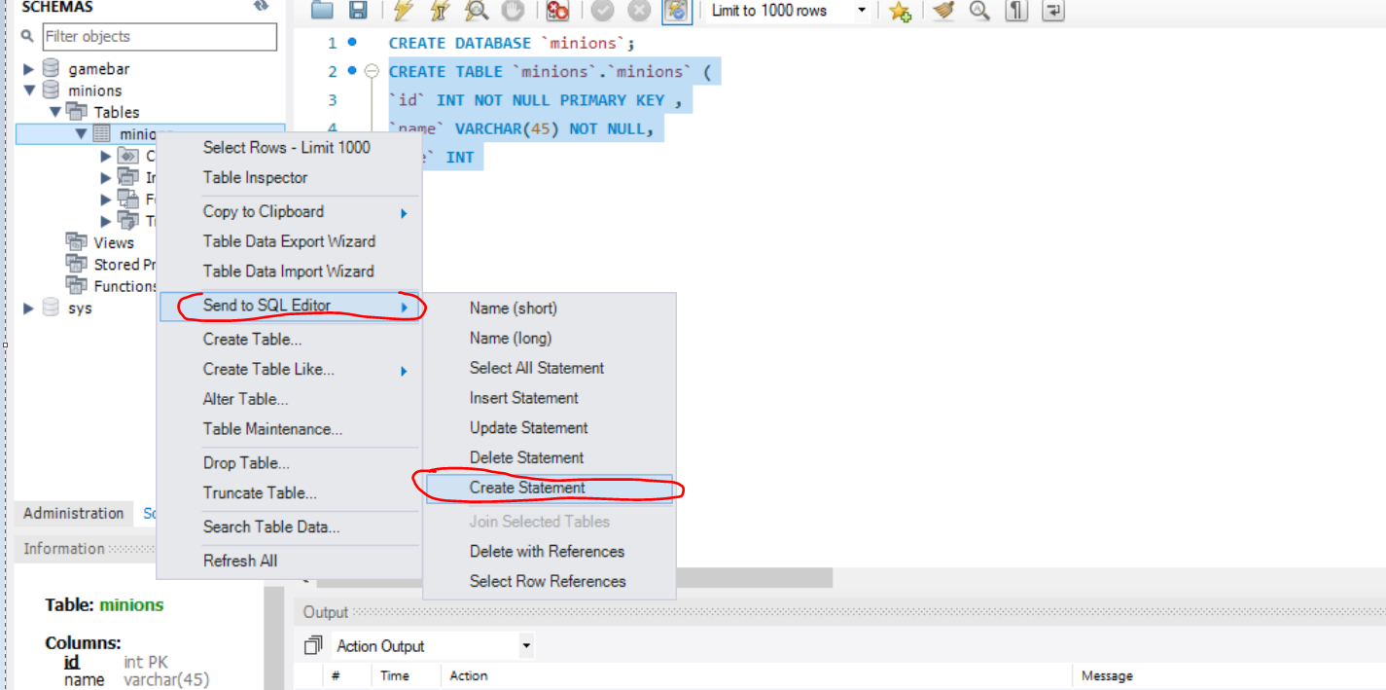

### 1.13. Advanced SQL queries

Сортира в alphabetic ред

SELECT `name` FROM `towns`

**ORDER BY** `name`; -

Сортира Double в низходящ ред

**SELECT** * **FROM** `employees`

**ORDER BY** `salary` **DESC;**

**ORDER BY** `salary`е същото като **ORDER BY** `salary` **ASC**

Тo show sorted only **some of the columns**

**SELECT** `first_name`, `last_name`, `job_title`, `salary` from `employees`

**ORDER BY** `salary` **DESC;**

**Нанасяне на нова информация на даден ред за дадена колона – за всички записи**

**UPDATE** `employees`

**SET** `salary` = `salary` * 1.1;

**WHERE** `id` > 0**;**

**Нанасяне на нова информация на даден ред за дадена колона – за определен запис**

**UPDATE** `employees`

**SET** `salary` = `salary` * 1.1;

**WHERE** `id` = 5**;**

### 1.14. E/R Diagram – диаграма на свързаността

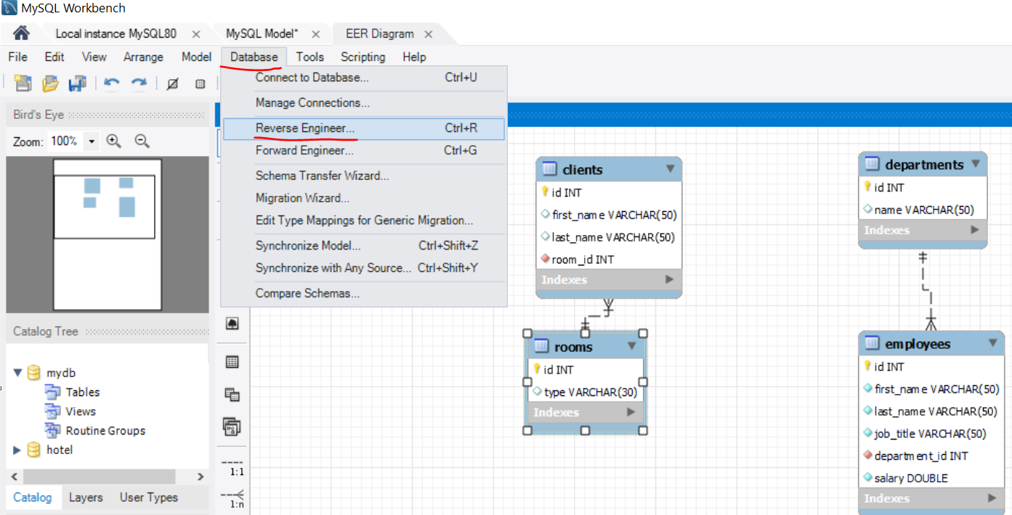

## 2. DML - BASIC CRUD (Create,Read,Update, Delete) OPERATIONS

Which of the following is NOT a valid SELECT statement ?

**a. SELECT (SELECT ID FROM EMPLOYEES) EMP FROM EMP**

b. SELECT * FROM Employees WHERE (SELECT SALARY FROM EMPLOYEES WHERE ID == 1) == 2000

c. SELECT * FROM (SELECT SALARY FROM EMPLOYEES WHERE ID == 1)

d. SELECT * FROM EMPLOYEES WHERE ID IN (1)

### 2.1. Query Basics

* Select first, last name and job title about employees:

**SELECT `**first_name`, `last_name`, `job_title` **FROM `**employees`**;**

* Select projects which start on 01-06-2003:

**SELECT * FROM `**projects` **WHERE `**start_date`='2003-06-01'**;**

* Inserting data into table – можем да insert-нем определени колонки, но тези които изпускаме не трябва да са NOT NULL. А тези, които са AUTO_INCREMENT – сами се увеличават дори да не вкарваме данни за тях

**INSERT INTO** projects(`name`, `start_date`)

**VALUES(**'Introduction to SQL Course', '2006-01-01'**);**

**Опция 3 – с SQL заявка и функция за определяне/за автоматично попълване**

**INSERT INTO** cards(card_number, card_status, bank_account_id)

**(**

SELECT REVERSE(full_name), 'Active', id

FROM clients

WHERE id>=191 AND id<=200

**);**

* Update several cells for specific rows:

**UPDATE `**projects`

**SET `**end_date` = '2006-08-31', `id` = 3;

**WHERE `**start_date` = '2006-01-01';

* Update specific cells/columns for all rows/records:

**UPDATE** `employees`

**SET** `salary` = `salary` * 1.1;

* Delete specific projects – изтрива целия ред

**DELETE FROM `**projects`

**WHERE `**start_date` = '2006-01-01';

### 2.2. Retrieving Data

#### Retrieve Records in SQL - using GUI:

* Get all information from a table

**SELECT * FROM** towns; - покажи текущите записи в базата данни от таблица towns.

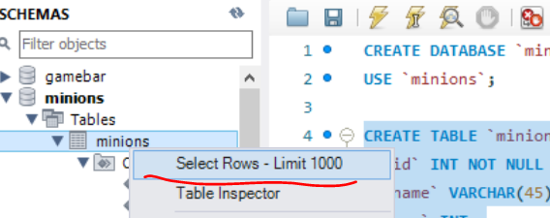

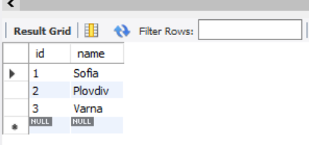

* **You can limit the columns and number of records**

**SELECT** first_name, last_name **FROM** employees **LIMIT** 5; - ограничи до 5 записа

#### Capabilities of SQL SELECT

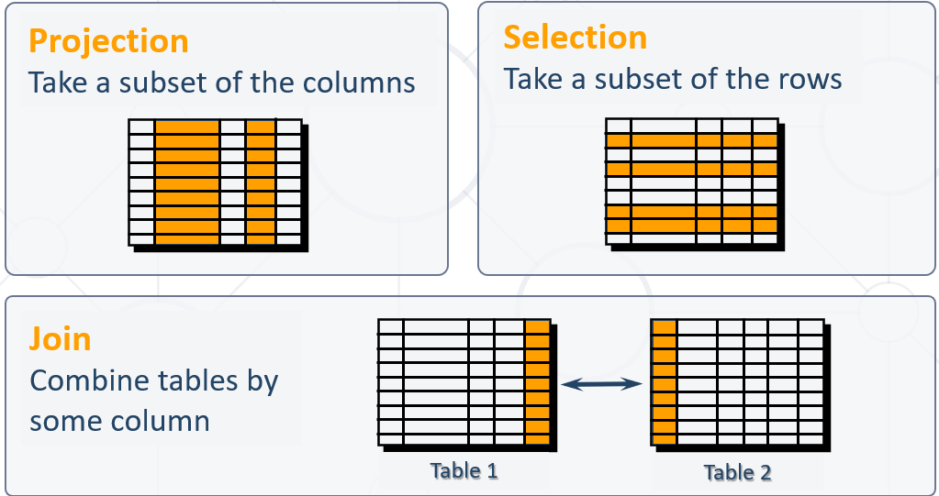

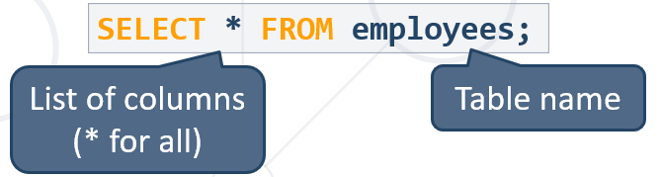

**SELECT `**id`, `first_name`, `last_name`, `job_title`

**FROM `**employees`

**ORDER BY `**id`;\

**WHERE**

**LIMIT 3;**

Всички колони плюс още колони

**SELECT *,`**id`, `first_name`, `last_name`, `job_title`

**FROM `**employees`

**ORDER BY `**id`;\

**WHERE**

**LIMIT 3;**

#### **Aliases(прякор/друго име)** rename a table or a column heading – **използваме задължително когато работим с повече от една таблица!!!**

**ВАЖНО – когато искаме да работим с колоната aliases – прякото име, то след AS използваме обикновени кавички ‘’, но в последствие използваме специалните кавички `` - НЕЕЕ Е ТАКА, МОЖЕ ДА СИ ИЗПОЛЗВАМЕ САМО ТИЛДА КАВИЧКИ!**

**SELECT** e.id **AS** 'No.',

e.first_name **AS** 'First Name',

e.last_name **AS** 'Last Name',

e.job_title **AS** 'Job Title'

**FROM** employees **AS** e

**ORDER BY** `Job title`;

Пример за Aliases когато работим едновременно с 2 таблици:

**SELECT** p.`peak_name`,

r.`river_name`,

**LOWER**(**CONCAT**(p.`peak_name`, **SUBSTRING**(r.`river_name`, 2))) **AS** `mix`

**FROM** `peaks` **AS** p, `rivers` **AS** r

**WHERE** **RIGHT**(**LOWER**(p.`peak_name`), 1) = **LEFT**(**LOWER**(r.`river_name`), 1)

**ORDER BY** `mix`;

**SELECT**

5+5 **AS** 'staticnumber',

`job_title` **AS** 'Job Title',

`id` **AS** 'No.'

**FROM `**employees**`;**

#### Concatenation – когато ги обединява в резултата от SELECT

**concat()** - returns the string that results from concatenating the arguments  - предефинирана функция в MySQL

* + String literals are enclosed in [**'**](**single** **quotes**)
  + Table and column names containing special symbols use [**`**] (**backtick**)

**SELECT concat**(`first_name`,' ',`last_name`**) AS** 'full_name'**,**

`job_title` **AS** 'Job Title',

`id` **AS** 'No.'

**FROM `**employees**`;**

#### Another function of concatenation is **concat_ws()** - stands for concatenate with **separator** and is a special form of **CONCAT()** – с първия стринг лепим останалите

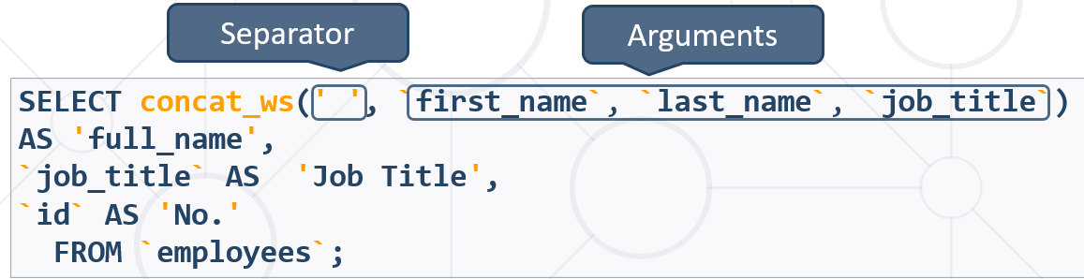

* Skip any **NULL** values after the separator argument.

#### Concatennating with + : Add 2 strings together:

Не работи както трябва

#### Filtering the Selected Rows

* Use **DISTINCT** to eliminate duplicate results – to eliminate all the duplicate records and fetching only unique records.

**SELECT DISTINCT** `first_name`

**FROM** `employees`;

Ако има повтарящи се имена, то покажи само веднъж повтарящото се име

* You can filter rows by specific conditions using the **WHERE** clause

**SELECT** `last_name`, `department_id`

**FROM** `employees`

**WHERE** `department_id` = 1;

* Other **logical operators** can be used for better control

**SELECT** `last_name`, `salary`

**FROM** `employees`

**WHERE** `salary` <= 20000;

* Conditions can be combined using **NOT**, **OR**, **AND** and brackets

**SELECT** `last_name` **FROM** `employees`

**WHERE NOT** (`manager_id` = 3 **OR** `manager_id` = 4);

* Using **BETWEEN** operator to specify a range:

**SELECT** `last_name`, `salary` **FROM** `employees`

**WHERE** `salary` **BETWEEN** 20000 **AND** 22000**; - работи включително**

**HAVING** `max_salary` **NOT BETWEEN** 30000 **AND** 70000

* Using **IN / NOT IN** to specify a set of values:

**SELECT** `first_name`, `last_name`, `manager_id`

**FROM** `employees`

**WHERE** `manager_id` **IN** (109, 3, 16); - **дали е измежду тези стойности**

SELECT * FROM `towns`

WHERE LOWER(SUBSTRING(`name`,1,1)) NOT IN('r', 'b', 'd')

ORDER BY `name`;

#### Comparing with NULL

* **NULL** is a special value that means missing value
  + Not the same as **0** or a blank space
* Checking for **NULL** values

Проверка за различно по този начин **!=** и по този начин **<>** не можем да правим с NULL!!!

**SELECT** `last_name`, `manager_id`

**FROM** `employees`

**WHERE** `manager_id` = **NULL; -ГРЕШНО!**

**SELECT** `last_name`, `manager_id`

**FROM** `employees`

**WHERE** `manager_id` **IS NULL;**

**SELECT** `last_name`, `manager_id`

**FROM** `employees`

**WHERE** `manager_id` **IS NOT NULL;**

#### Sorting with ORDER BY – може по две условия, отделяме със запетая

* Sort rows with the **ORDER BY** clause
  + **ASC**: ascending order, default
  + **DESC**: descending order

**SELECT** `last_name`, `hire_date`

**FROM** `employees`

**ORDER BY** `hire_date` **DESC, `**last_name` **ASC;**

Ако `hire_date` съвпада, то сортирай по следващ критерий **`**last_name`

#### Сортираме по много условия – отделяме със запетая

SELECT * FROM `employees`

ORDER BY `salary` DESC, `first_name` ASC, `last_name` DESC, `middle_name` ASC, `employee_id`;

#### Views – все едно си запазваме предефинирана заявка

* Views are **virtual tables** made from others tables, views or joins between them
* Usage:
  + To simplify writing complex queries
  + To limit access to data for certain users

**Views** – Example 1

**CREATE VIEW** `v_hr_result_set` **AS  
SELECT**

**CONCAT**(`first_name`,' ',`last_name`) **AS** 'Full Name',

`salary`

**FROM** `employees` **ORDER BY** `department_id`**;**

**SELECT * FROM** `v_hr_result_set`;

Example 2

**CREATE VIEW** `myview` **AS**

**SELECT** `first_name`, 5 **FROM** `employees`

**ORDER BY** `salary` **DESC**, `first_name` **ASC**, `last_name` **DESC**;

**SELECT * FROM** `myview`;

**DROP VIEW** `myview`; - заличи

### 2.3. Writing Data in Tables

#### The SQL **INSERT** command

**INSERT INTO** `towns` **VALUES** (33, 'Paris'); **- values for all columns сме длъжни да подадем**

**INSERT INTO** projects(`name`, `start_date`) - кажи колко колони ще нанасяш

**VALUES** ('Reflective Jacket', NOW())

Inserting data into table – можем да insert-нем определени колонки, но тези които изпускаме не трябва да са NOT NULL. А тези, които са AUTO_INCREMENT – сами се увеличават дори да не вкарваме данни за тях

#### **Bulk** **data** can be recorded in a single query, separated by comma

INSERT INTO `towns` (`id`, `name`)

VALUES

(1, 'Sofia'),

(2, 'Plovdiv'),

(3, 'Varna');

#### You can use existing records to create a **new table – копира както структурата, така и данните**

##### Пример 1

**CREATE TABLE** `customer_contacts`- new table name

**AS SELECT** `customer_id`, `first_name`, `email`, `phone`

**FROM** `customers`; - from existing table

##### Пример 2

**CREATE TABLE** `workers` **AS**

**SELECT** `first_name` **FROM** `employees`;

**CREATE TABLE** auto_filled **AS**

**SELECT** e.`first_name`,

d.`name` AS 'dept_name'

**FROM** `employees` AS e

**INNER JOIN** `departments` AS d

**ON** e.`department_id` = d.`department_id`;

#### **You can write into an existing table - – копира както структура, така и данни**

##### Пример 1

**INSERT INTO `**projects`(`name`, `start_date`)

**SELECT**

**CONCAT**(`name`,' ', ' Restructuring'),

NOW()

**FROM `**departments`;

Копира ги/добвя ги като данни за нови елементи от таблицата …. ☹

INSERT INTO `users`(`pk_users`)

SELECT

CONCAT(`id`, '',`username`) FROM `users`;

##### Пример 2

**CREATE TABLE** `workers`;

**INSERT INTO** `workers`

**SELECT** `first_name` **FROM** `employees` **WHERE** `salary` < 1000;

### 2.4. Updating Existing Records – UPDATE & DELETE

#### Updating data

##### Correcting/Updating records in SQL – using the GUI:

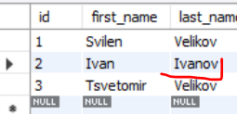

**UPDATE** `gamebar`.`employees` **SET** `last_name` = 'Ivanov' **WHERE** (`id` = '2');

**Възможност в WHERE да не участва ключовото поле: Preferences -> SQL Editor**

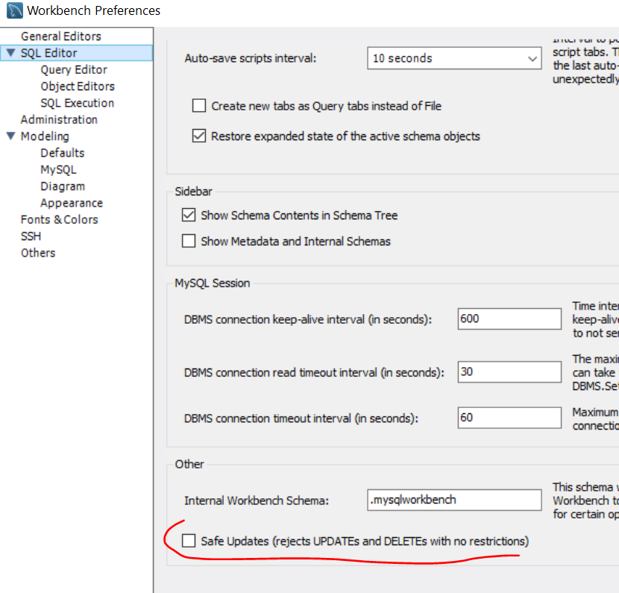

##### The SQL **UPDATE** command

**UPDATE** `employees`

**SET** `last_name` = 'Brown'

**WHERE** `employee_id` = 1;

**UPDATE** `employees`

**SET** `salary` = `salary` * 1.10,

`job_title` = **CONCAT**('Senior',' ', `job_title`)

**WHERE** `department_id` = 3;

* Note: Don't forget the **WHERE** clause!

#### Deleting Data

* **Deleteing row is part of DML**

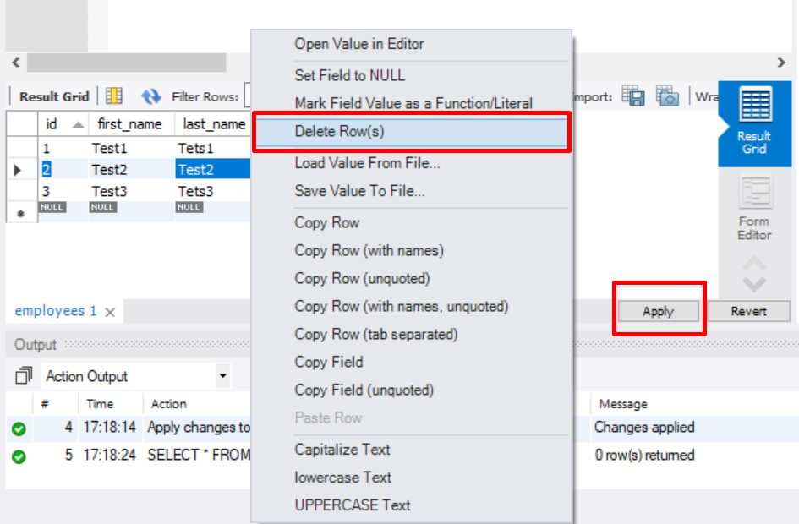

**DELETE FROM** `gamebar`.`employees` **WHERE** (`id` = '2');

* Deleting specific rows from a table
  + Note: Don't forget the **WHERE** clause!

**DELETE FROM** `employees`

**WHERE** `employee_id` = 1;

* Delete all rows from a table (**TRUNCATE** works faster than **DELETE)**

**TRUNCATE TABLE `users`;**

## 3.Built-in functions

<https://dev.mysql.com/doc/refman/8.0/en/functions.html> - функции, има и .xml functions и .json functions

### 3.1. String functions

* **SUBSTRING()** – extracts part of a string

**SUBSTRING(***String*, *Position***) – позицията/броенето започва от 1, а не от 0-левия**

**SUBSTRING(***String*, *Position*, *Length***)**

**SUBSTRING(***String* FROM *Position* FOR *Length***)**

SELECT SUBSTRING('SoftUni', 2); - връща 'oftUni'

SELECT SUBSTRING('SoftUni', 2, 3); - връща 'oft'

* **REPLACE** – replaces specific string with another
  + Performs a case-sensitive match

**REPLACE(***String*, *Pattern*, *Replacement***)** Pattern - string to replace replacement – with what to replace

SELECT **REPLACE**(`title`, 'The', '***')

AS 'Title' FROM `books`

WHERE **SUBSTRING**(title, 1, 3) = 'The';

SELECT REPLACE(`title`, 'The', '***')

AS `title` FROM `books`

WHERE `title` **LIKE** 'The%'

ORDER BY `id` ASC;

SELECT `first_name`, `last_name` FROM `employees`

WHERE **LOWER**(`job_title`) **NOT LIKE** '%engineer%'

ORDER BY `employee_id`;

* **Кастване/конвертиране от число към стринг**

**CAST** (1 as **CHAR**)

* **Chaining на функции –** една функция в друга
* **LTRIM & RTRIM –** remove spaces from either side of string

**LTRIM(***String***) –** от началото на стринга

**RTRIM(***String***)** – от края на стринга

* **CHAR_LENGTH –** count number of characters

**CHAR_LENGTH(***String***)**

SELECT `name` FROM `towns`

WHERE **CHAR_LENGTH**(`name`) IN(5,6)

ORDER BY `name` ASC;

* **LENGHT –** get number of used bytes (double for Unicode)

**LENGTH(**String**)**

Кирилицата заема по 2 байта, а латиницата по един

SELECT LENGTH('асц'); - връща 6

SELECT LENGTH('bdt'); - връща 3

* **LEFT & RIGHT** – get characters from beginning or end of string

**LEFT(***String*, *Count***) – от края**

**RIGHT(***String*, *Count***) – от началото**

SELECT `id`, `start`,

**LEFT**(`name`, 3) AS 'Shorthand'

FROM `games`;

* **LOWER & UPPER –** change letter casing – we use it for case insensitive search

**LOWER(***String***)**

**UPPER(***String***)**

* **REVERSE** – reverse order of all characters in string

**REVERSE(***String***)**

* **REPEAT –** repeat string

**REPEAT(***String, Count***)**

* **LOCATE –** locate specific pattern (substring) in string

**LOCATE(***Pattern, String,[Position]***) -** If omitted(пропуснато), position begins at 1

SELECT **LOCATE**('Big', `title`) FROM `books`; - връща позицията на която се появява Big в полето `title`. **Ако не намери, връща 0**

SELECT LOCATE('@', 'chavdar.mitkov@softuni.bg'); - връща 15

SELECT LOCATE('@', 'chavdar.mitkov@softu@ni.bg', 16); - връща 22

SELECT `user_name`, SUBSTRING(`email`, LOCATE('@', `email`)+1) AS `email provider` FROM `users`

ORDER BY `email provider` ASC, `user_name` ASC;

* **INSERT** – insert substring at specific position

**INSERT(***StringToInsertInto, Position, Length, Substring***)** като Length e броят символи за унищожение

SELECT INSERT(`title`, 1, 0, 'Ordered book: ') FROM `books`; **- вмъкни на позиция 1, без да триеш нищо(0) ‘Ordedered book: ’ пред всяко заглавие на книга**

SELECT *,

INSERT (`title`, LOCATE('Big', `title`), 3, 'Small') AS `newtitle` - новото заглавие ако съдържа Big, то го подмени с ‘Small’

FROM `books`

WHERE `title` LIKE **'%Big%'; - да не започва или да не завършва с Big**

* **SUBSTRING_INDEX** – insert substring at specific position

SUBSTRING_INDEX(string, delimiter, number)

Parameter Description

string Required. The original string

delimiter Required. The delimiter to search for

**number** Required. The number of times to search for the delimiter. Can be both a positive or negative number. If it is a positive number, this function returns all to the left of the delimiter. **If it is a negative number, this function returns all to the right of the delimiter.**

**SELECT**

user_name,

**SUBSTRING_INDEX**(email, '@', -1) **AS** 'email provider'

**FROM**

users;

### 3.2. Arithmetical Operators and Numeric Functions

Arithmetic expressions containing a null value are evaluated to null!!!

#### Arithmetical Operators

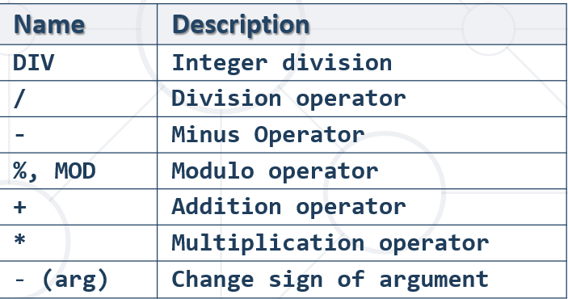

#### Numeric Functions

Used primarily for numeric **manipulation** and/or mathematical **calculations**

* **PI** – get the value of Pi (15 –digit precision)

**SELECT PI**() +0.000000000000000

* **ABS** – absolute value

**ABS(***Value***)**

* **SQRT** – square root

**SQRT(***Value***)**

* **POW** – raise value to desired exponent

**POW(***Value*, *Exponent***)**

* The **SUM()** function returns the total sum of a numeric column.

SELECT ROUND(SUM(`cost`), 2) AS `total_sum` FROM `books`;

#### Math Functions

* **CONV** – Converts numbers between different number bases

**CONV(***Value*, *from_base, to_base***)**

* **ROUND** – obtain desired precision

**ROUND(***Value*, *Precision***) –** Precision can be negative

SELECT **ROUND**(PI(), 2);

* **FLOOR** & **CEILING** – return the nearest integer

**FLOOR(***Value***) - надолу**

**CEILING(***Value***) - нагоре**

* **SIGN** – returns +1, -1 or 0, depending on value sign

**SIGN(***Value***)**

* **RAND** – get a random value in range [0,1)
  + If **Seed** is not specified, one is assigned at random – за хеширане, връща винаги една стойност за даден Seed

**RAND()** – връща random

**RAND(***Seed***) -** за хеширане, връща винаги една стойност за даден Seed

SELECT RAND('ssdfe'); винаги връща '0.15522042769493574'

### 3.3. Date Functions

* **EXTRACT** – extract a segment from a date as an integer

**EXTRACT(***Part* ***FROM*** *Date***)**

SELECT

**EXTRACT**(**DAY** FROM `born`) AS `day`,

`born` FROM `authors`;

SELECT EXTRACT(**YEAR** FROM '2022-05-23'); 2022

SELECT EXTRACT(**month** FROM '2022-05-23'); 5

SELECT EXTRACT(**day** FROM '2022-05-23'); 23

* **Get direct DAY, YEAR, MONTH, etc. without the function extract**

Директно си подаваме DAY, YEAR, MONTH от дадена дата

**DAY**(p.`date`) = 10

* **TIMESTAMPDIFF** – find difference between two dates

**TIMESTAMPDIFF(***Part, FirstDate, SecondDate***)**

* + ***Part*** can be any part and format of date or time

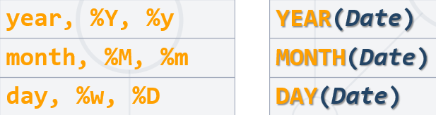

SELECT

**timestampdiff**(**MONTH**, `born`, `died`) AS `months_lived`,

`born` FROM `authors`;

* **DATE_FORMAT** – formats the date value according to the format

**SELECT DATE_FORMAT**('2017/05/31', '%Y %b %D') **AS** 'Date'**;**

SELECT DATE_FORMAT('2017/05/31 23:13:00', '%Y %b %D, %h:%i:%s') AS 'Date';

2017 May 31st, 11:13:00

Хардкорнати стойности %b за месец и %i за минута

SELECT `first_name` FROM `employees`

WHERE `department_id` IN(3, 10) && DATE_FORMAT(`hire_date`, '%Y') BETWEEN 1995 AND 2005

ORDER BY `employee_id`;

| **Specifier** | **Description** |
| --- | --- |
| %a | Abbreviated weekday name (Sun..Sat) |
| %b | Abbreviated month name (Jan..Dec) |
| %c | Month, numeric (0..12) |
| %D | Day of the month with English suffix (0th, 1st, 2nd, 3rd, …) |
| %d | Day of the month, numeric (00..31) |
| %e | Day of the month, numeric (0..31) |
| %f | Microseconds (000000..999999) |
| %H | Hour (00..23) |
| %h | Hour (01..12) |
| %I | Hour (01..12) |
| %i | Minutes, numeric (00..59) |
| %j | Day of year (001..366) |
| %k | Hour (0..23) |
| %l | Hour (1..12) |
| %M | Month name (January..December) |
| %m | Month, numeric (00..12) |
| %p | AM or PM |
| %r | Time, 12-hour (***hh:mm:ss*** followed by AM or PM) |
| %S | Seconds (00..59) |
| %s | Seconds (00..59) |
| %T | Time, 24-hour (***hh:mm:ss***) |
| %U | Week (00..53), where Sunday is the first day of the week; [WEEK()](https://dev.mysql.com/doc/refman/8.0/en/date-and-time-functions.html#function_week) mode 0 |
| %u | Week (00..53), where Monday is the first day of the week; [WEEK()](https://dev.mysql.com/doc/refman/8.0/en/date-and-time-functions.html#function_week) mode 1 |
| %V | Week (01..53), where Sunday is the first day of the week; [WEEK()](https://dev.mysql.com/doc/refman/8.0/en/date-and-time-functions.html#function_week) mode 2; used with %X |
| %v | Week (01..53), where Monday is the first day of the week; [WEEK()](https://dev.mysql.com/doc/refman/8.0/en/date-and-time-functions.html#function_week) mode 3; used with %x |
| %W | Weekday name (Sunday..Saturday) |
| %w | Day of the week (0=Sunday..6=Saturday) |
| %X | Year for the week where Sunday is the first day of the week, numeric, four digits; used with %V |
| %x | Year for the week, where Monday is the first day of the week, numeric, four digits; used with %v |
| %Y | Year, numeric, four digits |
| %y | Year, numeric (two digits) |
| %% | A literal % character |
| %***x*** | ***x***, for any “***x***” not listed above |

* **NOW** – obtain current date and time

**SELECT NOW();**

* **DATE_ADD**(`some_date`, **INTERVAL** *stepValue* *typeStep*)

SELECT `product_name`, `order_date`,

**DATE_ADD**(`order_date`, **INTERVAL** 3 **DAY**) AS 'pay_due'

FROM `orders`;

MINUTE

HOUR

DAY

WEEK

MONTH

QUARTER

YEAR

* Сравнение по дата

**SELECT** `deposit_group`, `is_deposit_expired`,

AVG(`deposit_interest`) AS `average_interest`

FROM `wizzard_deposits`

**WHERE `deposit_start_date` > '1985-01-01' когато формата на датата е този**

GROUP BY `deposit_group`, `is_deposit_expired`

ORDER BY `deposit_group` DESC, `is_deposit_expired` ASC;

<https://dev.mysql.com/doc/refman/8.0/en/date-and-time-functions.html>

### 3.4. Wildcards

#### Системни команди / System commands – като сървър (а не като клиент)

USE **INFORMATION_SCHEMA**;

SELECT * from **statistics**;

SHOW **tables**;

#### Вземи information данни за дадена таблица

**SELECT** `COLUMN_NAME` **FROM** `information_schema`.`columns`

**WHERE** `TABLE_SCHEMA` = 'custom-orm' **AND** `COLUMN_NAME` != 'id' **AND** `TABLE_NAME` = 'users';

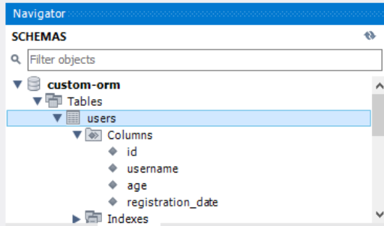 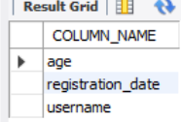

#### Used to substitute any other character(s) in a string

* + **'%'** - represents zero, one, or multiple characters
  + **'_'** - represents a single character
  + Can be used in combinations
* Used with **LIKE** operator in a **WHERE** clause
  + Similar to **Regular Expressions**

SELECT * FROM `books`

WHERE `title` LIKE '____Big%';

SELECT `user_name`, `ip_address` FROM `users`

WHERE `ip_address` LIKE '___.1%.%.___' **три символа.1няколко символа.няколко символа.три символа**

ORDER BY `user_name` ASC;

* Find any values that start with "a"

**WHERE** CustomerName **LIKE** 'a%';

* Find any values that have "r" in second position

**WHERE** CustomerName **LIKE** '_r%'**;**

* Finds any values that starts with "a" and ends with "o"

**WHERE** ContactName **LIKE** 'a%o'**;**

* Supported characters also include – **част от regex нещата искат да опишат тук**
  + **\** – specify prefix to treat special characters as normal – да го escape-нем
  + [**charlist**] – specifying which characters to look for
    - [!**charlist**] – **excluding** characters

SELECT * FROM `books`

WHERE `title` **LIKE** '____Big**\%**'; - обикновен процент

SELECT `first_name`, `last_name` FROM `employees`

WHERE LOWER(`job_title`) **NOT LIKE** '%engineer%'

ORDER BY `employee_id`;

### 3.5. Regex

SELECT * FROM `customers`

WHERE `city` **REGEXP '[a-c]%'**; - a, b or c - връща 0 или 1 ца – дали има или няма match

SELECT * FROM `customers`

WHERE `city` **NOT** **REGEXP '[a-c]%'**; - да не съдържа a, b or c

Using regular expression

* **REGEXP** - pattern matching using regular expressions

SELECT `employee_id`, `first_name`, `last_name`

FROM `employees`

WHERE `first_name` **REGEXP '^\[^K\]{3}\$';** връща 0 или 1 ца – дали има или няма match

Пример:

DELIMITER $$$$

**CREATE FUNCTION** ufn_is_word_comprised(setOfLetters VARCHAR(45), word VARCHAR(45))

**RETURNS BIT //връща нула или единица, както и при BOOLEAN**

**DETERMINISTIC**

**BEGIN**

**RETURN** word **REGEXP(concat**('^[', setOfLetters, ']+$')**); //поне един път трябва да има всяк**

**END;**

**$$$$**

**SELECT** ufn_is_word_comprised('oistmiahf', 'Sofia');

**SELECT** ufn_is_word_comprised('oistmiahf', 'halves');

* [**REGEXP_SUBSTR**(***expr***, ***pat***[, ***pos***[, ***occurrence***[, ***match_type***]]])](https://dev.mysql.com/doc/refman/8.0/en/regexp.html#function_regexp-substr)

Returns the substring of the string ***expr*** that matches the regular expression specified by the pattern ***pat***, NULL if there is no match. If ***expr*** or ***pat*** is NULL, the return value is NULL.

[REGEXP_SUBSTR()](https://dev.mysql.com/doc/refman/8.0/en/regexp.html#function_regexp-substr) takes these optional arguments:

* ***pos***: The position in ***expr*** at which to start the search. If omitted, the default is 1.
* ***occurrence***: Which occurrence of a match to search for. If omitted, the default is 1.
* ***match_type***: A string that specifies how to perform matching. The meaning is as described for [REGEXP_LIKE()](https://dev.mysql.com/doc/refman/8.0/en/regexp.html#function_regexp-like).

**SELECT REGEXP_SUBSTR(**`title`, ' [a-zA-Z]{2} '**) AS `**match`, `title` **FROM** `books`;

SELECT REGEXP_SUBSTR(`title`, '[a-zA-Z]+') AS `match`, `title` FROM `books`;

* [REGEXP_REPLACE(***expr***, ***pat***, ***repl***[, ***pos***[, ***occurrence***[, ***match_type***]]])](https://dev.mysql.com/doc/refman/8.0/en/regexp.html#function_regexp-replace)

Replaces occurrences in the string ***expr*** that match the regular expression specified by the pattern ***pat*** with the replacement string ***repl***, and returns the resulting string. If ***expr***, ***pat***, or ***repl*** is NULL, the return value is NULL.

**SELECT**

user_name,

**REGEXP_REPLACE**(email, '.*@', '') **AS** 'email provider'

**FROM**

users;

### 3.6. Условни конструкции

#### Използване на IFNULL функцията - Return the specified value IF the expression is NULL, otherwise return the expression:

**IFNULL**(`middle_name`), '') - ако е NULL, то го замести с празен стринг, иначе върни полето

#### IF condition – 1 – as a function – връща резултат

IF(condition, value_if_true, value_if_false)

**SELECT** IF(1 > 0, **'true'**, **'false'**); *--returns 'true'*

SELECT

`name` AS `game`,

/*DATE_FORMAT(start, '%k') AS `P`,*/

**IF**(DATE_FORMAT(start, '%k') >= 0 && DATE_FORMAT(start, '%k') < 12, 'Morning',

**IF**(DATE_FORMAT(start, '%k') >= 12 && DATE_FORMAT(start, '%k') < 18, 'Afternoon', 'Evening')) AS `Part of the Day`,

IF(`duration` <= 3 , 'Extra Short',

IF(`duration` <= 6, 'Short',

IF(`duration` <= 10, 'Long', 'Extra Long'))) AS `Duration`

FROM `games`;

#### IF condition – 2 – as a statement – не връща стойност

IF *search_condition* THEN *statement_list;*

[ELSEIF *search_condition* THEN *statement_list*] ...**;**

[ELSE *statement_list*]**;**

END IF

DELIMITER %%

CREATE PROCEDURE usp_raise_salary_by_id(id int)

BEGIN

START TRANSACTION;

**IF**((SELECT count(employee_id) FROM employees WHERE employee_id like id)<>1)

**THEN** ROLLBACK;

**ELSE**

UPDATE employees AS e SET salary = salary + salary*0.05

WHERE e.employee_id = id;

**END IF**;

END %%

**DECLARE** result DECIMAL;

**IF**(salary_emp < 30000) **THEN** **SET** result := 'Low'**; //при DECLARE използваме := за присвояване**

**ELSEIF** (salary_emp <= 50000) **THEN** **SET** result := 'Average'**; ELSEIF слято трябва да е**

**ELSE** **SET** result := 'High'**;**

**END IF;**

#### CASE condition - as a function – връща резултат

**Пример 1:**

SELECT

**CASE** `author_id`

**WHEN** 1 **THEN** 'Recommended for beginners' //Ако 1, върни еди какво си

**WHEN** 7 **THEN** 'Recommended for advanced'

**ELSE** 'All audiences'

**END**

AS `my_preference`

FROM `books`

WHERE SUBSTRING(title, 1, 3) = 'The';

**Пример 2:**

**SELECT** `name` AS 'game',

(**CASE** /*без променлива тук може*/

**WHEN** HOUR(`start`) **BETWEEN** 0 **AND** 11 **THEN** 'Morning'

**WHEN** HOUR(`start`) **BETWEEN** 12 **AND** 17 **THEN** 'Afternoon'

**ELSE** 'Evening'

**END**) **AS**  'Part of the Day',

(**CASE** /*без променлива тук може*/

**WHEN** `duration` **BETWEEN** 0 **AND** 3 **THEN** 'Extra Short'

**WHEN** `duration` **BETWEEN** 4 **AND** 6 **THEN** 'Short'

**WHEN** `duration` **BETWEEN** 7 **AND** 10 **THEN** 'Long'

**ELSE** 'Extra long'

**END**) **AS** 'Duration'

**FROM** `games`;

**Пример 3:**

SELECT

CASE

WHEN `age` BETWEEN 0 AND 10 THEN '[0-10]'

WHEN `age` BETWEEN 11 AND 20 THEN '[11-20]'

WHEN `age` BETWEEN 21 AND 30 THEN '[21-30]'

WHEN `age` BETWEEN 31 AND 40 THEN '[31-40]'

WHEN `age` BETWEEN 41 AND 50 THEN '[41-50]'

WHEN `age` BETWEEN 51 AND 60 THEN '[51-60]'

WHEN `age` >= 61 THEN '[61+]'

ELSE 'OUT of RANGE'

**END AS** **`age_group`,**

COUNT(`id`) AS `wizard_count`

FROM `wizzard_deposits`

**GROUP BY** **`age_group`**

ORDER BY `age_group`;

### 3.7. Цикли - **WHILE statement**

Пример с функция, където използваме **WHILE statement**

DELIMITER %%

CREATE FUNCTION ufn_IsWordComprised(setOfLetters VARCHAR (50), word VARCHAR (50))

RETURNS INT

deterministic

BEGIN

DECLARE index_letter INT;

DECLARE length_word INT;

DECLARE letter CHAR(1);

SET index_letter := 1;

SET length_word := CHAR_LENGTH(word);

**WHILE** (index_letter <= length_word)

**DO**

**SET** letter := SUBSTRING(word, index_letter, 1);

IF (LOCATE(letter, setOfLetters) > 0) **THEN SET** index_letter := index_letter + 1;

ELSE

RETURN 0;

END IF;

**END WHILE;**

RETURN 1;

END;

%%

**SELECT** ufn_IsWordComprised('oistmiahf', 'Sofia');

### 3.8. Цикли - **LOOP statement**

**LOOP**

...

-- terminate the loop

IF condition THEN

LEAVE [label];

END IF;

...

**END LOOP**;

## 4. Data Aggregation

### 4.1. Grouping - Consolidating Data Based On Criteria

* Grouping allows taking data into **separate groups** based on a **common property**
* Aggregating data allows us to group rows based on certain criteria.
* SQL provides a mechanism for aggregating data using the GROUP BY clause in a SELECT statement.
* SQL provides a standard set of functions that can be used over aggregated data

When we want to select and group by column or columns:

* Typically used with aggregate functions
* Can group by multiple columns. The result set will be grouped by the first column listed, then by the next.
* NULL values will be grouped together

Прави като представителна извадка - средната заплата на служителите в даден отдел.

select departmentId, *avg*(salary) as avgSalary

from Employees as e

group by departmentId;

**SELECT** e.`job_title`, count(employee_id)

**FROM** `employees` **AS** e

**GROUP BY** e.`job_title`;

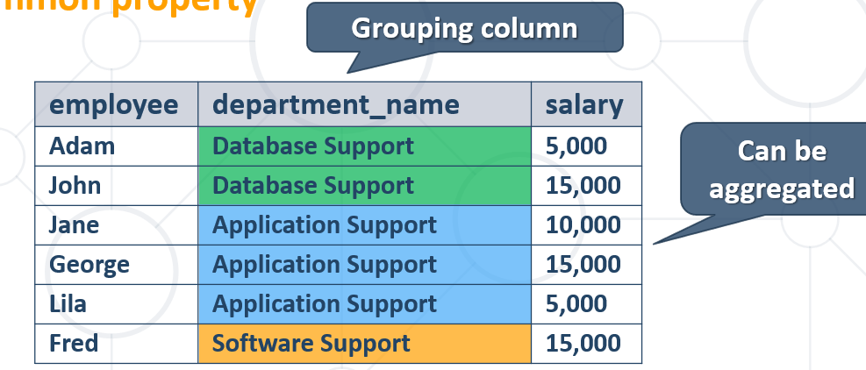

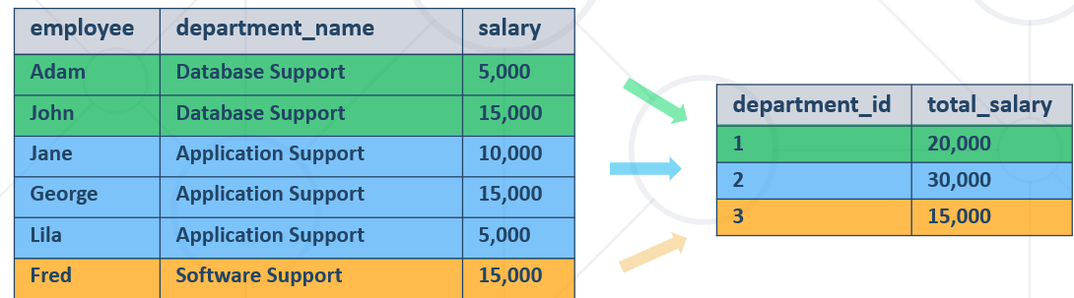

* **Групиране по 2 критерия/колони**

SELECT

`deposit_group`,

`magic_wand_creator`,

**MIN**(`deposit_charge`) AS 'min_deposit_charge'

FROM

`wizzard_deposits`

**GROUP BY** `deposit_group` , `magic_wand_creator`

ORDER BY `magic_wand_creator` ASC , `deposit_group`;

* With **GROUP BY** you can get each separate group and use an **"aggregate" function** over it (like Average, Min or Max)

### 4.2. Aggregate Functions

* Used to operate over **one** or **more** groups performing **data** **analysis** on every one

**Aggregating functions are:**

COUNT(*) - count of the selected rows

SUM(column) - sum of the values in given column from the selected rows – in PostgreSQL does not allow on varchar type for example. On MySQL return 0 on varchar!

AVG(column) - average of the values in given column

MAX(column) - the maximal value in given column

MIN(column) - the minimal value in given column

* They usually **ignore** **NULL** values

#### **COUNT -** counts the values (not nulls) in one or more columns based on grouping criteria

* Note that when we use **COUNT** we will ignore any employee with **NULL** salary.

SELECT `department_id`, **COUNT**(`first_name`) AS `Number of employees`

FROM `employees`

GROUP BY `department_id`

ORDER BY `department_id` ASC, `Number of employees` ASC;

**Използваме звезда за по-мързеливо и за да ни брои всички елементи**

SELECT `department_id`, **COUNT**(*) AS `Number of employees`

FROM `employees`

#### **SUM** - sums the values in a column

* If any department has no salaries **NULL** will be displayed.

SELECT e.`department_id`,   
**SUM**(e.`salary`) **AS** 'TotalSalary'

FROM `employees` **AS** e

GROUP BY e.`department_id`;

#### **MAX/MIN -** takes the maximum value in a column.

SELECT e.`department_id`,   
**MAX**(e.`salary`) **AS** 'Max Salary'

FROM `employees` **AS** e

GROUP BY e.`department_id`;

#### **AVG** calculates the average value in a column.

SELECT e.`department_id`,

ROUND(**AVG**(e.`salary`),2) AS 'Average Salary'

FROM `employees` AS e

GROUP BY e.`department_id`

ORDER BY e.`department_id`;

Използване на AVG в секцията ORDER BY

**SELECT** w.`deposit_group`

**FROM** `wizzard_deposits` **AS** w

**GROUP BY** w.`deposit_group`

**ORDER BY AVG**(w.`magic_wand_size`)

**LIMIT** 1;

### 4.3. HAVING - Using Predicates While Grouping

**Having Clause**

* The **HAVING** clause is used to filter data based on **aggregate** values.
  + We cannot use it **without** grouping **before** that
* Any Aggregate functions in the "**HAVING**" clause and in the "**SELECT**" statement are executed one time only
* **Unlike HAVING, the WHERE clause filters rows before the aggregation**

**SELECT** `deposit_group`,

**SUM**(`deposit_amount`) AS `total_sum`

FROM `wizzard_deposits`

**WHERE** `magic_wand_creator` = 'Ollivander family'

**GROUP BY** `deposit_group`

**HAVING** `total_sum` < 150000

**ORDER BY** `total_sum` DESC;

**SELECT** `deposit_group`,

*

FROM `wizzard_deposits`

**WHERE** `magic_wand_creator` = 'Ollivander family'

**GROUP BY** `deposit_group`

**HAVING**  **SUM**(`deposit_amount`) < 150000

**ORDER BY** `total_sum` DESC;

Filter departments which have **total** salary **less than** 25,000.

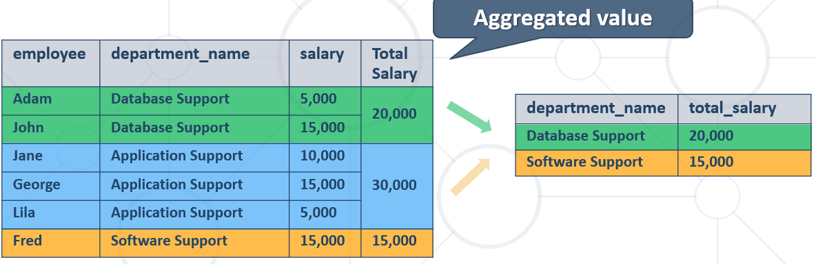

SELECT `department_id`,

SUM(`salary`) AS `TotalSalaryOfDepartment`

FROM `employees`

GROUP BY `department_id`

HAVING `TotalSalaryOfDepartment` < 120000;

### 4.4. MySQL **OFFSET and LIMIT** is used to specify which row should be fetched first.

SELECT e.`department_id`,

e.`salary` AS `third_highest_salary`

FROM `employees` AS e

WHERE (SELECT ine.`employee_id` FROM `employees` AS ine връща employee_id когато

WHERE ine.`department_id` = e.`department_id` департамента съвпада

GROUP BY ine.`salary` когато е третата най-висока заплата

ORDER BY `salary` DESC **LIMIT** 1 **OFFSET** 2 – **изкарай само един резултат, започвайки да търсиш след втория**

) = e.`employee_id` когато има съвпадение по employee_id

GROUP BY e.`department_id`

ORDER BY e.`department_id` ASC;

**LIMIT** **2, 1**; - започни да търсиш след втория запис, и ограничи до 1 запис изхода

### 4.5. Debug – EXPLAIN ANALYZE SELECT ..

**EXPLAIN SELECT** *, **SUBSTRING**(`title`, 1, 4) **FROM** `books` **LIMIT** 20 **OFFSET** 11;

**OFFSET** Отмести/започни от 11тия запис нататък

**еxplain**

прави план на заявката без да я изпълнява - има го и в MySQL - като не сме сигурни какво прави нашата заявка и за да не стане някаква беля

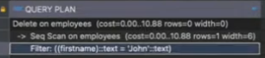

**explain analyze**

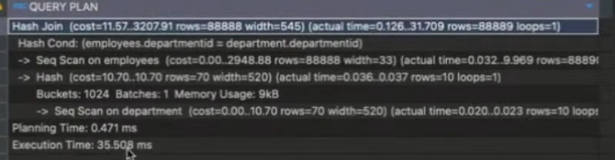

### 4.6. Вложени агрегиращи заявки

SELECT e.`first_name`, e.`last_name`, e.`department_id`

FROM `employees` AS e

WHERE e.`salary` > (

SELECT

AVG(inn.`salary`) FROM `employees` AS inn - намери средната заплата

WHERE inn.`department_id` = e.`department_id` - ако средната заплата след групиране отговаря на запла-

GROUP BY inn.`department_id` тата на всеки пореден служител от съотв. департамент

)

ORDER BY e.`department_id`, e.`employee_id`

LIMIT 10;

**Друго решение на същата задача – използваме сега само един Alias:**

**SELECT** `first**_**name`, `last**_**name`, `department**_**id`

**FROM** `employees` **AS** e

**WHERE** e.salary > (**SELECT** AVG(salary) **FROM** employees **WHERE** department_id = e.department_id **GROUP BY** department_id)

**ORDER BY** `department**_**id`, `employee**_**id`

**LIMIT** 10

**ВАЖНО – при update и използване на нестнати операции**

**UPDATE** employees_clients AS **ec**

SET ec.employee_id =

(

SELECT **ec**.employee_id – **от същата таблица ec реално**

GROUP BY **ec**.employee_id

ORDER BY COUNT(**ec**.employee_id) ASC, **ec**.employee_id ASC

LIMIT 1

)

WHERE ec.employee_id = ec.client_id;

### 4.7. Невложени заявки вършещи работа като вложени заявки

SELECT

SUM(`hw`.`deposit_amount` - `gw`.`deposit_amount`) AS 'sum_difference'

FROM

`wizzard_deposits` AS `hw`,

`wizzard_deposits` AS `gw`

WHERE

`gw`.`id` - `hw`.`id` = 1;

## 5. Table relations – видове връзки

### 5.1. Database design

**Steps in database design**

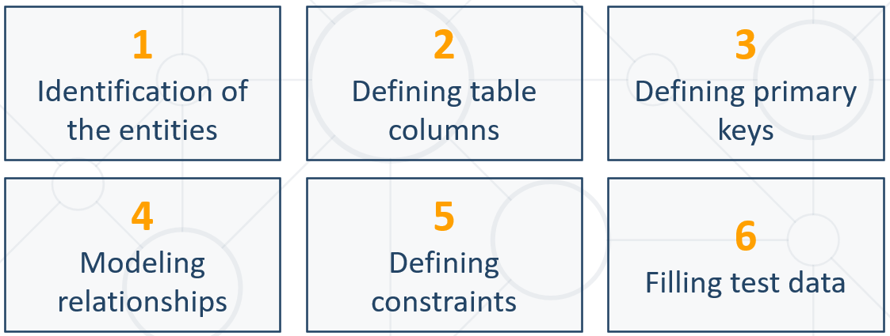

**1. Identification of Entities**

* Entity tables represent objects from the real world
  + Most often they are nouns in the specification

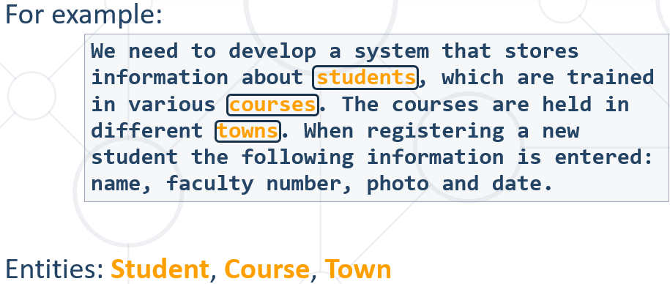

**2. Define Table Columns**

* Columns are clarifications for the entities in the text of the specification, for example:

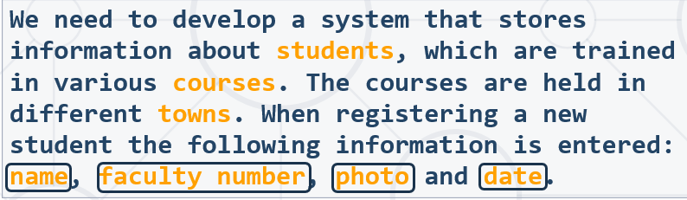

* Students have the following characteristics:
  + Name, faculty number, photo, date of enlistment and a list of courses they visit

**3. Defining primary keys**

* Always define an additional column for the primary key
  + Don't use an existing column (for example SSN)
  + Can be an integer number
  + **Must be** declared as **a PRIMARY KEY**
  + Use **AUTO_INCREMENT** to implement auto-increment
  + **Put the primary key as a first column**
* Exceptions
  + Entities that have well known ID, e.g. countries (BG, DE, US) and currencies (USD, EUR, BGN)

**4. Modelling relationships**

* Relationships are dependencies between the entities:

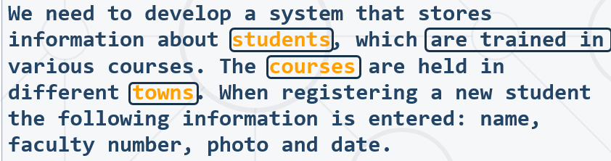

* + "Students are trained in courses" – **many-to-many** relationship.
  + "Courses are held in towns" – **many-to-one** (or many-to-many) relationship

**5. Defining constraints**

**6. Filling test data**

### 5.2. Table relations

* **Relationships** between tables are based on interconnections: **PRIMARY KEY** / **FOREIGN KEY**

**Foreign Key**

CREATE TABLE `Orders` (  
    `OrderID` int NOT NULL,  
    `OrderNumber` int NOT NULL,  
    `PersonID` int,  
    PRIMARY KEY (`OrderID`),

CONSTRAINT `fk_source_target`  
    FOREIGN KEY `Orders`(`PersonID`) REFERENCES `Persons`(`PersonID`)  
);

SQL FOREIGN KEY on ALTER TABLE

ALTER TABLE `products`

ADD CONSTRAINT `fk_products_categories` FOREIGN KEY `products`(`category_id`) REFERENCES `categories`(`id`);

* The **foreign key** is an **identifier** of a record located in another table (usually its primary key)
* By using relationships we avoid repeating data in the database
* Relationships have multiplicity:

#### **One-to-many** – e.g. mountains / peaks - от едната страна на foreign key полето трябва да е UNIQUE

**Много модели на един производител в случая**

CREATE TABLE `**manufacturers**`(

`manufacturer_id` INT AUTO_INCREMENT PRIMARY KEY NOT NULL, **- реално е UNIQUE това поле**

`name` VARCHAR(45),

`established_on` DATE

);

**Foreign key е от Many страната на релацията.**

CREATE TABLE `**models**`(

`model_id` INT UNIQUE NOT NULL,

`name` VARCHAR(45),

`**manufacturer_id**` INT NOT NULL - **а това поле не е UNIQUE**

);

ALTER TABLE `**models**`

**ADD CONSTRAINT** `fk_models_manufacturers`

FOREIGN KEY `models`(`manufacturer_id`)

REFERENCES `manufacturers`(`manufacturer_id`);

INSERT INTO `manufacturers` (`name`, `established_on`)

VALUES

('BMW', '1916-03-01'),

('Tesla', '2003-01-01'),

('Lada', '1966-05-01');

INSERT INTO `models` (`model_id`, `name`, `manufacturer_id`)

VALUES

(101, 'X1', 1),

(102, 'i6', 1),

(103, 'Model S', 2),

(104, 'Model X', 2),

(105, 'Model 3', 2),

(106, 'Nova', 3);

#### **One-to-one** – e.g. example driver / car – и от двете страни на foreign key полето трябва да е **UNIQUE**

CREATE TABLE `people`(

`person_id` INT AUTO_INCREMENT **PRIMARY KEY** NOT NULL,

`first_name` VARCHAR(45),

`salary` DECIMAL(10, 2) NOT NULL,

`passport_id` INT **UNIQUE** NOT NULL – **това поле е UNIQUE**

);

CREATE TABLE `passports`(

`passport_id` INT **UNIQUE** NOT NULL, - **и това поле също е UNIQUE**

`passport_number` VARCHAR(45) UNIQUE

);

ALTER TABLE `people`

**ADD CONSTRAINT** `fk_people_passports`

FOREIGN KEY `people`(`passport_id`)

REFERENCES `passports`(`passport_id`);

INSERT INTO `people` (`first_name`, `salary`, `passport_id`)

VALUES

('Roberto', 43300.00, 102),

('Tom', 56100.00, 103),

('Yana', 60200.00, 101);

INSERT INTO `passports` (`passport_id`, `passport_number`)

VALUES

(101, 'N34FG21B'),

(102, 'K65LO4R7'),

(103, 'ZE657QP2');

Всяко поле AUTO_INCREMENT и всяко поле PRIMERY KEY реално е **UNIQUE**

#### Many-to-many – e.g. student / course – изпълнява се с composite primary key и mapping table

##### **Мapping table** and **composite primary key** - пример за many-to-many relations

CREATE TABLE `students`(

`student_id` INT AUTO_INCREMENT **PRIMARY KEY** NOT NULL,

`name` VARCHAR(45)

);

CREATE TABLE `exams` (

`exam_id` INT NOT NULL **PRIMARY KEY**,

`name` VARCHAR(30)

);

**Важно: за да работи foreign key, трябва да има primary key в таблиците**

CREATE TABLE `students_exams`(

`student_id` INT,

`exam_id` INT,

**CONSTRAINT** **pk**_students_exams

**PRIMARY KEY** `students_exams`(`student_id`, `exam_id`),

**CONSTRAINT** fk_students_exams_students

**FOREIGN KEY** `students_exams`(`student_id`)

**REFERENCES** `students`(`student_id`),

**CONSTRAINT** fk_students_exams_exams

**FOREIGN KEY** `students_exams`(`exam_id`)

**REFERENCES** `exams`(`exam_id`)

);

##### Без композитен ключ, използваме DISTINCT за да няма повторения

#08. Count Likes and Comments

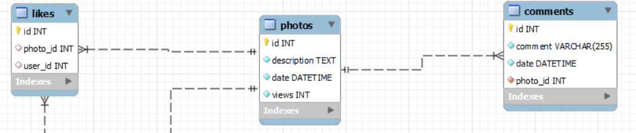

В случая, като съединим 3 таблици, и за всеки различен лайк на снимка има примерно по два коментара.

**Как процедираме – пускаме първо заявката със звезда, и виждаме какво става.**

**SELECT** *

**FROM** `photos` AS p

**LEFT JOIN** `likes` AS l

**ON** l.`photo_id` = p.`id`

**LEFT JOIN** `comments` AS c

**ON** c.`photo_id` = p.`id`;

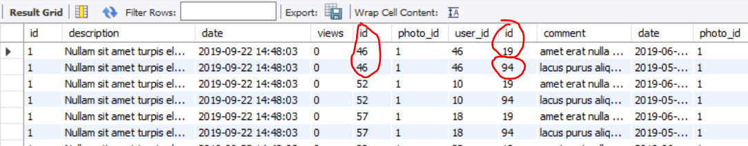

**SELECT** p.`id`, COUNT(**DISTINCT** l.`id`) **AS** `likes_count`, COUNT(**DISTINCT** c.`id`) **AS** `comments_count`

**FROM** `photos` **AS** p

**LEFT JOIN** `likes` **AS** l

**ON** l.`photo_id` = p.`id`

**LEFT JOIN** `comments` **AS** c

**ON** c.`photo_id` = p.`id`

**GROUP BY** p.`id`

**ORDER BY** `likes_count` DESC, `comments_count` DESC, p.`id` ASC;

#### Self-referencing

CREATE TABLE `teachers`(

`teacher_id` INT PRIMARY KEY,

`name` VARCHAR(20),

`manager_id` INT,

**CONSTRAINT** fk_teachers_teachers

**FOREIGN KEY** `teachers`(`manager_id`)

**REFERENCES** `teachers`(`teacher_id`)

);

INSERT INTO `teachers` (`teacher_id`, `name`)

VALUES

(101, 'John'),

(102, 'Maya'),

(103, 'Silvia'),

(104, 'Ted'),

(105, 'Mark'),

(106, 'Greta');

UPDATE `teachers` SET `manager_id` = null WHERE (`name` = 'John');

UPDATE `teachers` SET `manager_id` = 106 WHERE (`name` = 'Maya');

UPDATE `teachers` SET `manager_id` = 106 WHERE (`name` = 'Silvia');

UPDATE `teachers` SET `manager_id` = 105 WHERE (`name` = 'Ted');

UPDATE `teachers` SET `manager_id` = 101 WHERE (`name` = 'Mark');

UPDATE `teachers` SET `manager_id` = 101 WHERE (`name` = 'Greta');

**Друг пример за self-referencing**

SELECT e.`employee_id`, e.`first_name`, m.`employee_id` AS 'manager_id', m.`first_name` AS 'manager_name'

**FROM** `employees` **AS** e

**JOIN** `employees` **AS** m

**ON** e.`manager_id` = m.`employee_id`;

### 5.3. JOIN - Retrieving Related Data

**Joins**

* Table relations are useful when combined with JOINS
* With JOINS we can get data from two tables **simultaneously**
  + JOINS require at least two tables and a "**join condition**"

Example:

SELECT * FROM table_a  
 **JOIN** table_b **ON** - добави таблица b към таблица а  
 table_b.common_column = table_a.common_column; **да са равни**

За използването на JOIN не е необходимо използването на външен ключ (foreign key)

**SELECT** v.`driver_id`, v.`vehicle_type`,

CONCAT(c.`first_name`, ' ', c.`last_name`) AS 'driver_name'

**FROM** `vehicles` **AS** v

**JOIN** `campers` **AS** c - добави таблица campers към таблица vehicles

**ON** v.`driver_id` = c.`id`;

### 5.4. Cascade Operations

* Cascading allows when a change is made to certain entity, this change to apply to all related entities

Ако изтриеш нещо, изтрий всичко по веригата.

Ако update-неш нещо, то го update-ни навсякъде по веригата.

#### CASCADE DELETE

* **CASCADE** can be either **DELETE** or **UPDATE**.
* Use **CASCADE** **DELETE** when:
  + The related entities are **meaningless** without the "main" one
* Do **not** use **CASCADE** **DELETE** when:
  + You make "**logical delete**"
  + You preserve **history**
* Keep in mind that in more complicated relations it won't work with **circular** references

Пример 1:

* Write a query to create a one-to-many relationship
* When an mountains gets removed from the database, all of his peaks are deleted too

CREATE TABLE `mountains`(

`id` INT PRIMARY KEY AUTO_INCREMENT,

`name` VARCHAR(20) NOT NULL

);

CREATE TABLE `peaks`(

`id` INT PRIMARY KEY AUTO_INCREMENT,

`name` VARCHAR(20) NOT NULL,

`mountain_id` INT,

CONSTRAINT `fk_mountain_id`

FOREIGN KEY(`mountain_id`)

REFERENCES `mountains`(`id`)

**ON DELETE CASCADE**

);

Пример 2:

CREATE TABLE drivers(

driver_id INT PRIMARY KEY,

driver_name VARCHAR(50)

);

CREATE TABLE cars(

car_id INT PRIMARY KEY,

driver_id INT,

CONSTRAINT fk_car_driver FOREIGN KEY(driver_id)

REFERENCES drivers(driver_id) **ON DELETE CASCADE**  
);

#### CASCADE UPDATE

* Use **CASCADE** **UPDATE** when:
  + The primary key is **NOT** identity (not **auto-increment**) and therefore it **can** be changed
  + Best used with **UNIQUE** constraint
* Do **not** use **CASCADE** **UPDATE** when:
  + The primary is identity (**auto-increment**)
* Cascading can be avoided using triggers or procedures

CREATE TABLE drivers(

driver_id INT PRIMARY KEY,

driver_name VARCHAR(50)

);

CREATE TABLE cars(

car_id INT PRIMARY KEY,

driver_id INT,

CONSTRAINT fk_car_driver FOREIGN KEY(driver_id)

REFERENCES drivers(driver_id) **ON UPDATE CASCADE**  
);

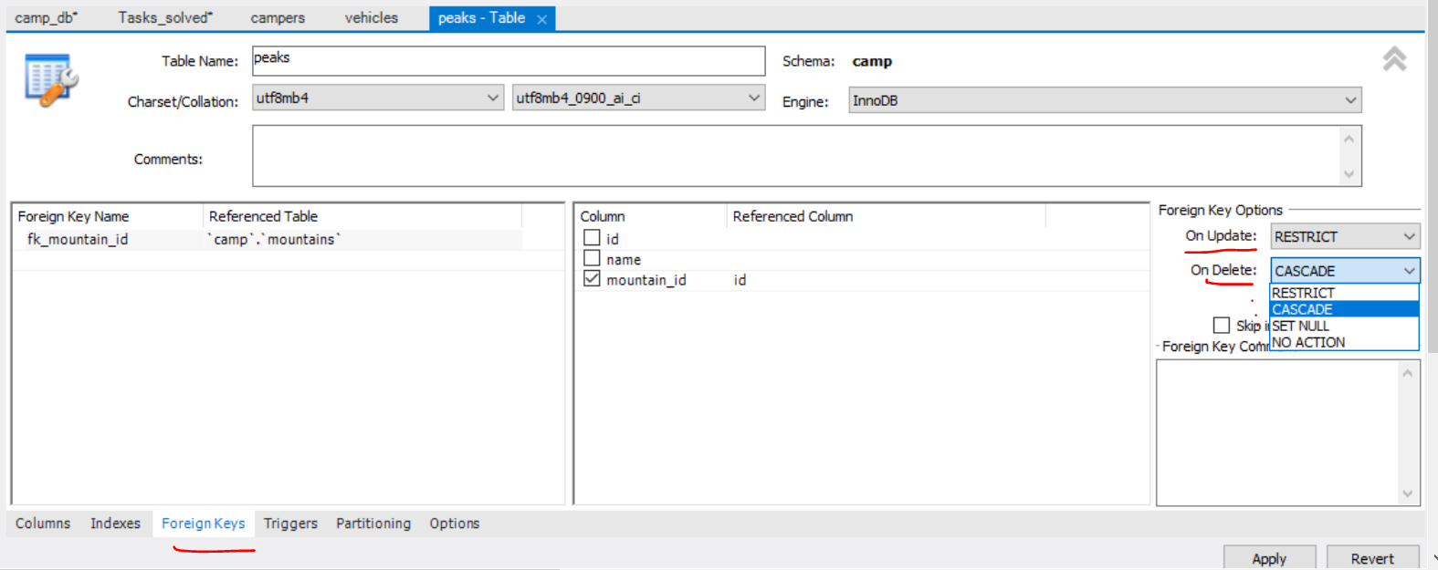

### 5.5. E/R Diagram

Понякога първо си чертаем E/R диаграмата, и след това пишем заявките

**Relational Schema**

* **Relational schema** of a DB is the collection of:
  + The schemas of all tables
  + Relationships between the tables
  + Any other database objects (e.g. constraints)
* The relational schema describes the **structure** of the database
  + Doesn't contain data, but **metadata**
* Relational schemas are **graphically** displayed in Entity / Relationship diagrams (**E/R Diagrams**)

#### Reverse engineering



Добра практика е да слагаме префикс на името на всяка таблица, която създаваме. Например:

my_Products

my_Clients

my_personnel

или

wp_posts

wp_links

wp_commentmeta

wp_comments

wp_users

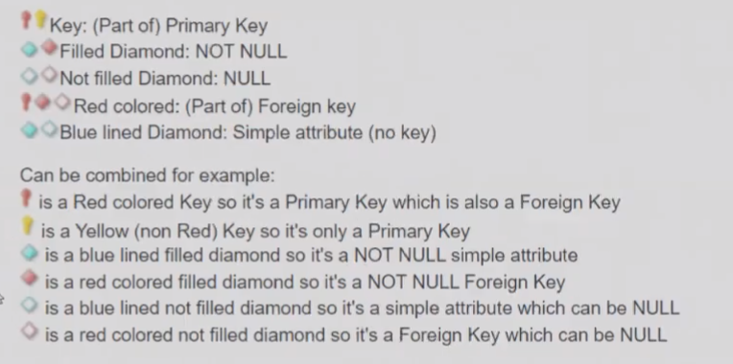

**В persons таблицата пишем дефиницията за foreign key**

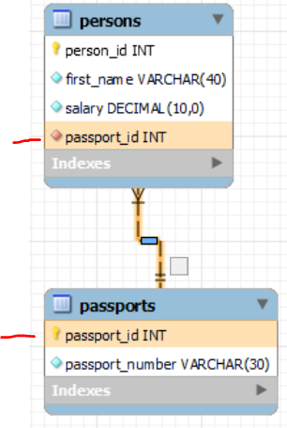

Като посочим стрелката, и ни показва кои полета са свързани.

**Как тълкуваме стрелката** - в случая таблица persons (parent) има foreign key passport_id, който сочи към таблица passports (child дете) с ключ passport_id (или passport_id на persons сочи към passport_id на passports).

Какво означава линията:

* + - **Плътна линия означава в двойката баща-дете, че и двете са задължителни/и двете са primary keys**
    - **Прекъсната линия означава, че в двойката parent-child не са задължителни и двете**

#### Syncronize model – от E/R диаграма към създаване на база данни

Каквото сме си нарисували на диаграма, го направи на истинска база

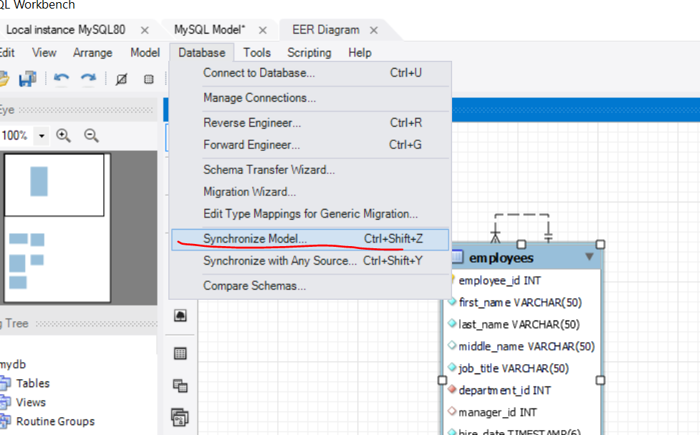

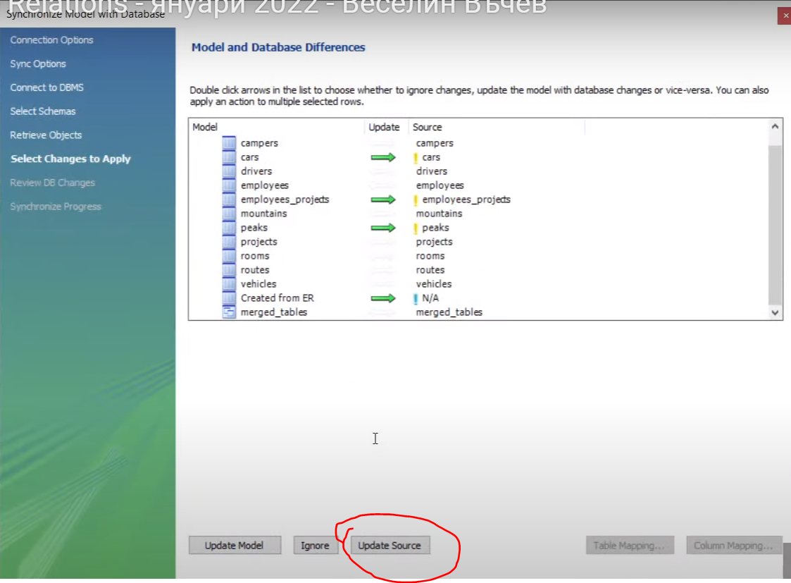

## 6. JOINS

### 6.1. Gathering Data From Multiple Tables

Можем да правим JOIN и на таблици без foreign keys

* Sometimes you need data from several tables:

**Cartesian product – всяко от едната таблица с всяко от другата таблица**

* Each row in the first table is paired with **all** the rows in the second table
  + When there is **no relationship** defined between the two tables

A Cartesian product is formed when:

* A join condition is omitted - когато нямаме никакъв condition
* A join condition is invalid
* All rows in the first table are joined to all rows in the second table

To avoid a Cartesian product, always include a valid join condition!

### 6.2. Union

* UNION combines the results from several SELECT statements
* The columns **count**, **types** and **order(поредност)** should match

SELECT FIRST_NAME AS NAME

FROM EMPLOYEES

**UNION**

SELECT LAST_NAME AS NAME

FROM EMPLOYEES

### 6.3. JOINS – used to collect data from two or more tables

Different types of joins include:

* Natural joins
* Join with USING clause
* Inner joins with ON clause
* Left, right and full outer joins
* Self joins
* Cross joins

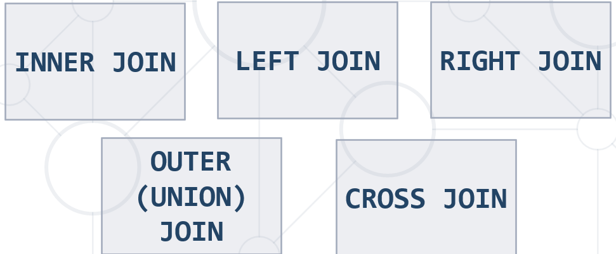

#### NATURAL JOIN

The NATURAL JOIN combines the rows from two tables that have equal values in all matched by name columns.

Natural Join in SQL refers to **joining two or more tables based on common columns, which have the same name and data type**. We do not need to specify the column used for joining two tables in natural join. Natural join is used to retrieve data from more than one table in a single place.

SELECT *\** FROM ORDERS NATURAL JOIN CUSTOMERS;

#### USING clause

If several columns have the same names, we can limit the NATURAL JOIN to only one of them by the USING clause:

The USING clause **specifies which columns to test for equality when two tables are joined**. It can be used instead of an ON clause in the JOIN operations that have an explicit join clause.

SELECT E.EMPLOYEE_ID, E.LAST_NAME, D.LOCATION_ID, D.DEPARTMENT_NAME

FROM EMPLOYEES E

JOIN DEPARTMENTS D

USING (DEPARTMENT_ID);

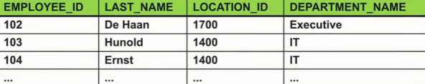

#### JOIN(== INNER JOIN) with ON clause

* To specify arbitrary conditions or specify columns to join, the ON clause is used
* Used very often
* взема сечението
* Produces a set of records which **match in both tables**

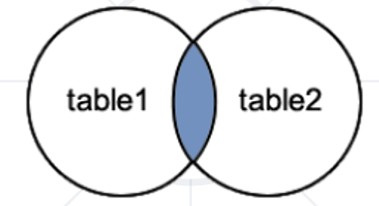

SELECT e.`first_name`, d.`name` AS 'dept_name'

FROM `employees` AS e **- таблица 1 = e**

**INNER JOIN** `departments` AS d **- таблица 2 = d**

**ON** e.`department_id` = d.`department_id`;

**Пример 1:**

//Селектирай служителите, само които имат проекти

SELECT e.`employee_id`, e.`first_name`, p.`name` AS `project_name`

FROM `employees` AS e

**INNER JOIN** `employees_projects` AS ep

**ON** e.`employee_id` = ep.`employee_id`;

Или можем и така:

**SELECT** e.`employee_id`, e.`first_name`, p.`name` **AS** `project_name`

**FROM** `employees` **AS** e

**LEFT JOIN** `employees_projects` AS ep //вземи всичко отляво (таблицата employees като първа таблица)

**ON** e.`employee_id` = ep.`employee_id`

**WHERE** ep.`project_id` **IS NOT NULL**; //НО само когато за employee_id от employees ИМА ep.`project_id`

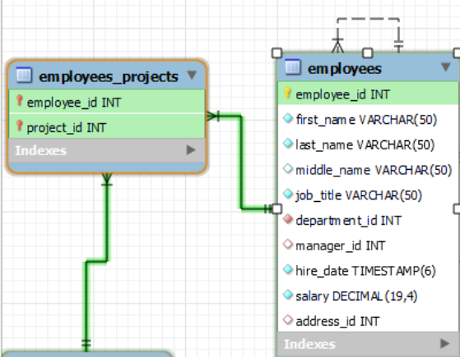

**Пример 2:**

SELECT E.EMPLOYEE_ID, E.LAST_NAME, E.DEPARTMENT_ID, D.DEPARTMENT_ID, D.DEPARTMENT_NAME

FROM EMPLOYEES E

JOIN DEPARTMENTS D

ON (E.DEPARTMENT_ID = D.DEPARTMENT_ID)

WHERE D.DEPARTMENT_NAME != 'Department 2';

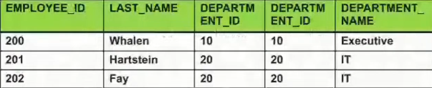

#### LEFT JOIN (== LEFT OUTER JOIN)

* A join that returns all the rows from the left table and the matched ones from the right
* If no match, the result is NULL on the right
* Matches every entry in **left** table regardless of match in the **right**

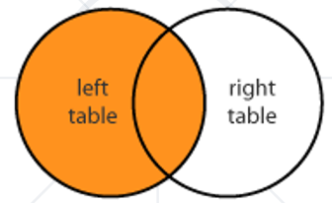

Example, see powerpoint presentation

**Пример 1:**

Тези колеги, които не са в нито един проект

**SELECT** e.`employee_id`, e.`first_name`

**FROM** `employees` **AS** e

**LEFT JOIN** `employees_projects` **AS** ep //вземи всичко отляво (таблицата employees като първа таблица)

**ON** e.`employee_id` = ep.`employee_id`

**WHERE** ep.`project_id` **IS NULL** //когато за employee_id от employees няма ep.`project_id`

**ORDER BY** e.`employee_id` DESC

**LIMIT** 3;



**Пример 2:**

SELECT E.EMPLOYEE_ID, E.LAST_NAME, E.DEPARTMENT_ID, D.DEPARTMENT_ID, D.DEPARTMENT_NAME

FROM EMPLOYEES E

LEFT JOIN DEPARTMENTS D

ON (E.DEPARTMENT_ID = D.DEPARTMENT_ID);

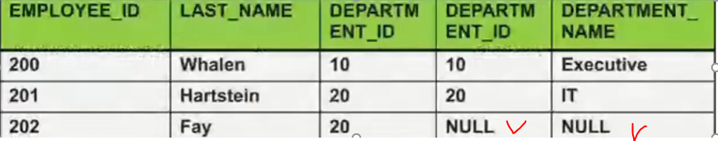

#### RIGHT JOIN (== RIGHT OUTER JOIN)

* A join that returns all the rows from the right table and the matched ones from the left
* If no match, the result is NULL on the left
* Matches every entry in **right** table regardless of match in the **left**

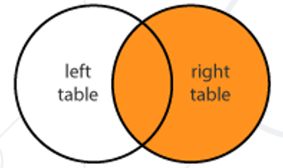

Example, see powerpoint presentation

SELECT E.EMPLOYEE_NAME, D.DEPARTMENT_ID, D.DEPARTMENT_NAME

FROM EMPLOYEES E

RIGHT JOIN DEPARTMENTS D

ON (E.DEPARTMENT_ID = D.DEPARTMENT_ID);

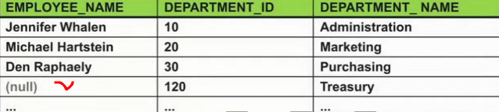

#### FULL JOIN (==FULL OUTER JOIN)

* Not implemented in MySQL
* A join that returns all the rows where there is a match (left or right)
* If no match, the result is NULL on the respective side - left or right
* Разликата с Cartesion product е че в долния пример няма дуплициране на данни
* Returns all records in both tables regardless of **any** match
  + Less useful than **INNER**, **LEFT** or **RIGHT** **JOINs**
  + We can use **UNION** of a **LEFT** and **RIGHT** **JOIN**

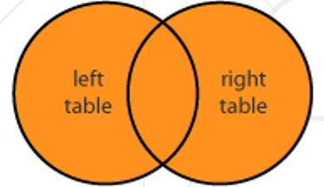

OUTER JOIN – взема всичко без сечението, но не е имплементирано в MySQL

SELECT E.EMPLOYEE_NAME, D.DEPARTMENT_ID, D.DEPARTMENT_NAME

FROM EMPLOYEES E

**FULL OUTER JOIN** DEPARTMENTS D

ON (E.DEPARTMENT_ID = D.DEPARTMENT_ID);

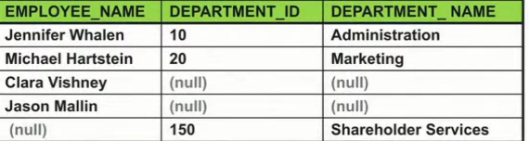

FULL JOIN == FULL OUTER JOIN – взема всичко **включително и сечението**, но не е имплементирано в MySQL

В MySQL нямаме нито FULL OUTER JOIN нито само FULL JOIN, и в MySQL тази операция се постига чрез UNION of LEFT and RIGHT JOIN.

#### UNION of LEFT and RIGHT JOIN

SELECT students.name, courses.name

FROM students

**LEFT JOIN** courses

**ON** students.course_id = courses.id

**UNION**

SELECT students.name, courses.name

FROM students

**RIGHT JOIN** courses

**ON** students.course_id = courses.id

Example, see powerpoint presentation

#### Self joining

Self join means to join a table to itself.

Always used with table aliases.

SELECT *CONCAT* (E.FIRST_NAME, ' ', E.LAST_NAME) AS EMPLOYEE_NAME,

SELECT *CONCAT* (M.FIRST_NAME, ' ', M.LAST_NAME) AS MANAGER_NAME

FROM EMPLOYEES E

JOIN EMPLOYEES M ON (E.MANAGER_ID = M.EMPLOYEE_ID);

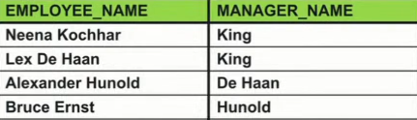

#### Three way join

A three-way join is a join of three tables.

SELECT E.EMPLOYEE_ID, L.CITY, D.DEPARTMENT_NAME

FROM EMPLOYEES E

JOIN DEPARTMENTS D ON D.DEPARTMENT_ID = E.DEPARTMENT_ID

JOIN LOCATIONS L ON D.LOCATION_ID = L.LOCATION_ID;

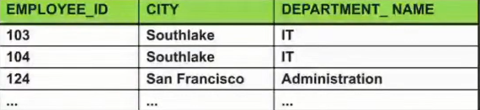

#### CROSS JOIN

* Produces a set of associated rows of two tables
  + Multiplication of each row in the first table with each in second
  + The result is a **Cartesian** product, when there's **no condition** in the **WHERE** clause
  + Not used often as **a lot of duplication**

SELECT E.LAST_NAME, D.DEPARTMENT_NAME

FROM EMPLOYEES E

CROSS JOIN DEPARTMENTS D;

### 6.4. Set operations

Set operations in SQL is a type of operations which allows **the results of multiple queries to be combined into a single result set**.

Set operators in SQL include UNION, INTERSECT, and EXCEPT, which mathematically correspond to the concepts of union, intersection and set difference.

#### UNION operator

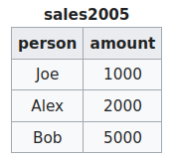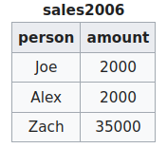

SELECT * FROM sales2005

UNION

SELECT * FROM sales2006;

Note that there are two rows for Joe because those rows are distinct across their columns. There is only one row for Alex because those rows are not distinct for both columns.

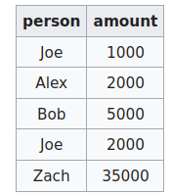

UNION ALL gives different results, because it will not eliminate duplicates. Executing this statement:

SELECT * FROM sales2005

UNION ALL

SELECT * FROM sales2006;

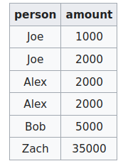

#### INTERSECT operator

The following example INTERSECT query returns all rows from the Orders table where Quantity is between **50 and 100.**

SELECT *

FROM   Orders

WHERE  Quantity BETWEEN 1 AND 100

INTERSECT

SELECT *

FROM   Orders

WHERE  Quantity BETWEEN 50 AND 200;

#### EXCEPT operator

The following example EXCEPT query returns all rows from the Orders table where Quantity is between 1 and 49, and those with a Quantity between 76 and 100.

Worded another way; the query returns all rows where the Quantity is between 1 and 100, apart from rows where the quantity is between 50 and 75.

SELECT *

FROM   Orders

WHERE  Quantity BETWEEN 1 AND 100

EXCEPT

SELECT *

FROM   Orders

WHERE  Quantity BETWEEN 50 AND 75;

### 6.5. Subqueries – една заявка в друга заявка

* Subqueries – SQL query inside a larger one
* Can be nested in **SELECT, INSERT, UPDATE, DELETE**
  + Usually added within a **WHERE** clause

SELECT COUNT(e.employee_id) AS `count`

FROM employees AS e

WHERE e.salary >

(

SELECT AVG(salary) AS 'average_salary' FROM employees

);

**Конкатениране на повече от две таблици**

SELECT e.`first_name`, e.`last_name`, t.`name` , adr.`address_text`

**FROM** `employees` **AS** e

**JOIN** `addresses` **AS** adr

**ON** e.`address_id` = adr.`address_id`

**JOIN** `towns` **AS** t

**ON** adr.`town_id` = t.`town_id`

**ORDER BY** e.`first_name` ASC, e.`last_name` ASC

**LIMIT** 5;

**WHERE и ORDER BY ги слагаме след всички JOIN**

**SELECT** c.`country_code`, m.`mountain_range`, p.`peak_name`, p.`elevation`

**FROM** `countries` **AS** c

**JOIN** `mountains_countries` **AS** mc

**ON** c.`country_code` = mc.`country_code`

**JOIN** `mountains` **AS** m

**ON** mc.`mountain_id` = m.`id`

**JOIN** `peaks` AS p

**ON** m.`id` = p.`mountain_id`

**WHERE** c.`country_code` = 'BG' AND p.`elevation` > 2835

**ORDER BY** p.`elevation` DESC;

**Когато трябва да визуализираме променена стойност на дадена клетка**

SELECT e.`employee_id`, e.`first_name`,

(

CASE

WHEN YEAR(p.`start_date`) > 2004

THEN NULL - променената стойност е NULL

ELSE p.`name`

END

)

AS 'project_name'

FROM `employees` AS e

JOIN `employees_projects` AS ep

ON e.`employee_id` = ep.`employee_id`

JOIN `projects` AS p

ON p.`project_id` = ep.`project_id`

WHERE e.`employee_id` = 24

ORDER BY `project_name`;

**#15. *Continents and Currencies**

#групирана по два критерия връща за всеки континент и за всяка валута, то по колко пъти се използва дадена валута

**SELECT** contr.`continent_code`, contr.`currency_code`,

**COUNT**(*) **AS** `currency_usage`

**FROM** `countries` **AS** contr

**GROUP BY** contr.`continent_code` , contr.`currency_code`

**HAVING** `currency_usage` > 1 #всички валути, които се използват в даден континент в повече от една държава

**AND**

#от всички валути колко пъти са използвани, сравни само тази коя е използвана най-много пъти

`currency_usage` = (**SELECT** #c.`currency_code`,

**COUNT**(*) **AS** `most_used_currency`

**FROM** `countries` **AS** c

**WHERE** c.`continent_code` = contr.`continent_code`

**GROUP BY** c.`currency_code`

**ORDER BY** `most_used_currency` **DESC**

**LIMIT** 1)

**ORDER BY** contr.`continent_code` **ASC**, contr.`currency_code` **ASC**;

### 6.5. Subqueries example - more

Given tables Employees with columns Id, Name, Email and Salary, EmployeeDeparments with columns Id, EmployeeId, DepartmentId and Departments with columns Id, Name write an SQL query to return the names of Deparments along with the number of employees in each department as Name and Count columns

Note: Use LEFT joins

SELECT D.Name,

(SELECT count(*) FROM EmployeeDeparments EEDD

WHERE **EEDD.DepartmentId** = **ED.DepartmentId** AND EEDD.EmployeeId IS NOT NULL) AS `COUNT`

FROM Departments D

LEFT JOIN EmployeeDeparments ED

ON ED.DepartmentId = D.Id

LEFT JOIN Employees E

ON ED.EmployeeId = E.Id

GROUP BY D.Name;

Групира се таблица/резултат от JOIN-овете, и там реда с Administrative си стои и е 1 на брой. Във вложената селект заявка **ED.DepartmentId** представлява тази съща резултатна таблицa като в случая на Administrative записа **ED.DepartmentId** е **null**. Съществува и друга опция даден служител да не се води в никой отдел - **ED.DepartmentId** може да не null, а **EEDD.EmployeeId** да е null.

Name             COUNT

---------------  ----------

Administrative       0

Business Develo  1

HR                        2

IT                          1

—----------------------

### 6.6. More hacks

#### UPDATE JOIN

#Task 3 - Update - version in which we have employees with 0 clients – вложена заявка

**UPDATE** employees_clients **AS** ec

**SET** ec.employee_id =

(

SELECT COUNT(e.id) FROM employees AS e

LEFT JOIN **(SELECT * from employees_clients)** AS emcl **- нова инстанция на същата таблица**

ON emcl.employee_id = e.id

GROUP BY e.id

ORDER BY COUNT(e.id) ASC, e.id ASC

LIMIT 1

)

WHERE ec.employee_id = ec.client_id;

Или така също става

**UPDATE** `products` **AS** prr

**JOIN** `categories` **AS** c

**ON** prr.`category_id` = c.`id`

**JOIN** `reviews` AS r

**ON** r.`id` = prr.`review_id`

**SET** prr.`price` = prr.`price` * 0.7

**WHERE** c.`name` = 'Phones and tablets' AND r.`rating` < 4;

#### DELETE JOIN

**Вариант 1 - Работи**

**DELETE** emp **FROM** employees **AS** emp **– изтрий от таблицa emp**

**LEFT JOIN** employees_clients **AS** ec

**ON** ec.employee_id = emp.id

**WHERE** ec.client_id **IS NULL**; - тези, служители, които нямат клиенти, при JOIN имат cliend_id да е NULL

Вариант 2

DELETE FROM employees WHERE id = **– изтрий от таблицa emp**

(

SELECT emp.id FROM **(SELECT * FROM employees)** AS emp **- нова инстанция на същата таблица**

**LEFT JOIN** employees_clients AS ec

**ON** ec.employee_id = emp.id

**WHERE** ec.client_id **IS NULL** - тези, служители, които нямат клиенти, при JOIN имат cliend_id да е NULL

)

#### GROUP BY plus JOIN

SELECT CONCAT(emp.first_name, ' ', emp.last_name) AS 'name',

emp.started_on,

COUNT(ec.employee_id) AS count_of_clients

FROM employees AS emp

LEFT **JOIN** employees_clients AS ec

ON ec.employee_id = emp.id

**GROUP BY** ec.employee_id

ORDER BY count_of_clients DESC, emp.id ASC

LIMIT 5;

## 7. DCL - Data Control Language

Grant SELECT,INSERT,UPDATE,DELETE on Employee To User1;

Revoke INSERT On Employee To user1;

Deny Update On Employee to user1;

GRANT in first case we gave privileges to user User1 to do SELECT, INSERT, UPDATE and DELETE on the table called employees.

REVOKE with this command we can take back privilege to default one, in this case, we take back command INSERT on the table employees for user User1.

DENY is a specific command. We can conclude that every user has a list of privilege which is denied or granted so command DENY is there to explicitly ban you some privileges on the database objects.:

## 8. Database Programmability

Да избягваме в практиката функции и процедури в MySQL

**Важно: ПЪРВО разписваме проста заявка, и след това я копираме/слагаме в структурата на съответната функция/процедура/тригер**

**We can optimize with User-defined Functions.**

**Transactions improve security and consistency.**

**Stored Procedures encapsulate repetitive logic.**

**Triggers execute before certain events on tables.**

### 8.1. User-Defined Functions

Encapsulating Custom Logic

* Extend the functionality of a MySQL Server
  + **Modular=functional** programming – write **once**, call it **any number** of times
  + Faster execution – doesn't need to be reparsed and reoptimized with each use
  + Break out complex logic into **shorter code blocks**
* Functions can be:
  + Scalar – return **single value** or **NULL**
  + Table-Valued – return a **table**

Само при използване на **DECLARE** използваме за присвояване/задаване на стойност **:=**

**DRY – Don’t Repeat Yourself** принцип

#### Creating Functions

**DELIMITER** $$$$ - **начало на разделител**

**CREATE FUNCTION** ufn_count_employees_by_town(`town_name` **VARCHAR(20)**)

**RETURNS** DOUBLE - **какъв тип връща функцията, незадължителен елемент**

**DETERMINISTIC – при едни и същи входни данни един и същи резултат връща**

**BEGIN**

**DECLARE** e_count DOUBLE; - **деклариране на променлива**

**SET** e_count **:=** (SELECT COUNT(employee_id) FROM employees AS e - **за присвояване**

INNER JOIN addresses AS a ON a.address_id = e.address_id

INNER JOIN towns AS t ON t.town_id = a.town_id

WHERE t.name = town_name);

**RETURN** e_count; - **каква стойност връща функцията, незадължителен елемент**

**END**;

$$$$ - **край на разделител**

DELIMITER $$$$

CREATE FUNCTION ufn_count_employees_by_town(`town_name` VARCHAR(20))

RETURNS INT

DETERMINISTIC

BEGIN

DECLARE e_count INT;

SET e_count **:=** (SELECT COUNT(e.`employee_id`) FROM `employees` AS e

INNER JOIN `addresses` AS a ON a.`address_id` = e.`address_id`

INNER JOIN `towns` AS t ON t.`town_id` = a.`town_id`

WHERE t.`name` = `town_name`);

RETURN e_count;

Или директно връщаме резултата

RETURN(

(SELECT COUNT(e.`employee_id`) FROM `employees` AS e

INNER JOIN `addresses` AS a ON a.`address_id` = e.`address_id`

INNER JOIN `towns` AS t ON t.`town_id` = a.`town_id`

WHERE t.`name` = `town_name`));

END;

$$$$

Deterministic vs. non-deterministic functions

#### Executing and Dropping Stored Functions

**И така изпълняваме функцията**

**SELECT** ufn_count_employees_by_town('Sofia');

**SELECT** ufn_get_salary_level(51000.0);

**DROP FUNCTION** ufn_get_salary_level;

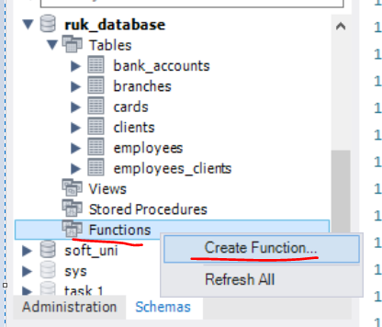

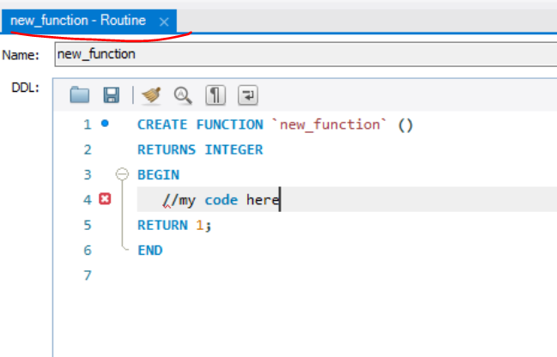

### 8.2. Stored Procedures

Sets of Queries Stored On DB Server

* Stored procedures are logic removed from the application and placed on the database server.
  + Can greatly cut down traffic on the network
  + Improve the security of the database server
  + Separate data access routines from the business logic
* Stored procedures are accessed by programs using different platforms and API's.
* **Нямаме return при процедури**

#### Creating Stored Procedures

**DELIMITER %%**

**CREATE PROCEDURE** usp_select_employees_by_seniority()

**BEGIN**

SELECT *

FROM employees

WHERE ROUND((DATEDIFF(NOW(), hire_date) / 365.25)) < 15;

**END %%**

#### Executing and Dropping Stored Procedures

* Executing a stored procedure by **CALL**

**CALL** usp_select_employees_by_seniority();

* **DROP PROCEDURE**

**DROP PROCEDURE** usp_select_employees_by_seniority;

#### Defining Parameterized Procedures

* To define a parameterized procedure use the syntax:

**CREATE PROCEDURE** usp_procedure_name

(parameter_1_name parameter_type,

parameter_2_name parameter_type,…)

**Пример 1:**

DELIMITER $$

CREATE PROCEDURE usp_select_employees_by_seniority(min_years_at_work INT)

BEGIN

SELECT first_name, last_name, hire_date,

ROUND(DATEDIFF(NOW(),DATE(hire_date)) / 365.25,0) AS 'years'

FROM employees

WHERE ROUND(DATEDIFF(NOW(),DATE(hire_date)) / 365.25,0) > min_years_at_work

ORDER BY hire_date;

END $$

CALL usp_select_employees_by_seniority(15);

**Пример 2:**

Task 2 -Employees Promotion

DELIMITER $

CREATE PROCEDURE usp_raise_salaries (dept_name VARCHAR(45))

BEGIN

/*business logic*/

UPDATE `employees` AS e

JOIN `departments` AS d

ON d.`department_id` = e.`department_id`

SET e.`salary` = e.`salary` * 1.05

WHERE d.`name` = dept_name;

SELECT e.`first_name`, e.`salary` FROM `employees` AS e

JOIN `departments` AS d

ON d.`department_id` = e.`department_id`

WHERE d.`name` = dept_name

ORDER BY e.`first_name`, e.`salary`;

END $

CALL usp_raise_salaries('Finance');

Пример 3:

DELIMITER %%%

CREATE PROCEDURE usp_get_towns_starting_with (starts_with VARCHAR(20))

BEGIN

SELECT `name` FROM `towns`

WHERE `name` **LIKE** **concat**(starts_with, '%') - **тук конкатенираме**

ORDER BY `name`;

END; %%%

CALL usp_get_towns_starting_with('S');

#### Returning Values Using OUTPUT Parameters

DELIMITER $$

**CREATE PROCEDURE** usp_add_numbers (first_number INT, second_number INT, **OUT** **result** INT)

**BEGIN**

**SET** **result** = first_number + second_number;

END $$

**Все едно процедурата работи като функция:**

**SET** **@**answer=0;

**CALL** usp_add_numbers(5, 6,**@**answer);

SELECT **@**answer;

Функции и процедури рядко се използват – те са бизнес логика, която не е редно да стои при базата данни на сървъра.

### 8.3. TCL - Transactions – a kind of a stored procedure

* Една процедура има една или няколко SQL заявки, които се изпълняват една след друга.
* При транзакции, може да се създаде логика, която да изпълнява една или друга заявка или всички заявки, ИЛИ никоя от заявките да не се изпълни
* Transaction is a **sequence of actions SQL queries** (database operations) executed as a whole
  + Either **all** of them complete successfully or **none** of them
* Example of transaction
  + A bank transfer from one account into another (withdrawal + deposit)
    - If either the withdrawal or the deposit fails **the whole operation is cancelled**
* Транзакцията се пише вътре в процедура(stored procedure)
* Ако имаме много заявки, и ако някоя се чупи, то можем да зададем ROLLBACK и на всички изпълнени до момента транзакции

**ACID model is used by InnoDB engine на MySQL**

**Transactions Behavior**

* Transactions guarantee the **consistency** and the **integrity** of the database.
  + All changes in a transaction are temporary
  + Changes are persisted when **COMMIT** is executed – всичко е временно докато не commit-нем

COMMIT е зададен като default - да

* + At any time all changes can be canceled by **ROLLBACK**
* All of the operations are executed as a whole.

Само намаля в случая:

**START TRANSACTION;**

UPDATE `employees` SET `salary` = `salary` - 1000 WHERE `employee_id` = 1;

Отново само намаля в случая:

**START TRANSACTION;**

UPDATE `employees` SET `salary` = `salary` - 1000 WHERE `employee_id` = 1;

**COMMIT;**

Намалянето не се извършва:

**START TRANSACTION;**

**UPDATE** `employees` **SET** `salary` = `salary` - 1000 **WHERE** `employee_id` = 1;

**ROLLBACK;**

#Task 3

DELIMITER %%

**CREATE PROCEDURE** usp_raise_salary_by_id(id int)

**BEGIN**

**DECLARE** does_exist INT;

**START TRANSACTION**;

**UPDATE** employees SET salary = salary *1.05 WHERE employee_id = id; - **update-ни всички, но не записвай нищо още реално**

SET does_exist **:=** (SELECT COUNT(*) FROM employees WHERE employee_id = id);

**IF** (does_exist = 1)

**THEN** **COMMIT**; **- сега ги презапиши!!!**

**ELSE**

**ROLLBACK**;

**END IF**;

**END** %%

**CALL** usp_raise_salary_by_id(1);

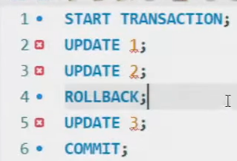

Modern DBMS servers have built-in transaction support

* + Implement "ACID" transaction
  + hgfds
* ACID means:
  + **A**tomicity
  + **C**onsistency
  + **I**solation
  + **D**urability

#13. Withdraw Money

DELIMITER $$$

**CREATE PROCEDURE** usp_withdraw_money(account_id INT, money_amount DECIMAL(19, 4))

**BEGIN**

DECLARE bal DECIMAL(19, 4);

START TRANSACTION;

SET bal := (SELECT a.`balance` FROM `accounts` AS a WHERE a.`id` = account_id) - money_amount;

UPDATE `accounts`

SET `balance` = `balance` - money_amount

WHERE `id` = account_id;

**IF** (money_amount > 0 AND bal > **0.0000**) **THEN COMMIT**;

**ELSE ROLLBACK;**

**END IF;**

**END;**

$$$

DROP PROCEDURE usp_withdraw_money;

CALL usp_withdraw_money(1, 20);

### 8.4. Triggers – като Event Listener

Event-listener – чакаме нещо да се случи, и тогава прави нещо

* Triggers - small programs in the database itself, activated by the database events application layer
  + UPDATE, DELETE or INSERT queries
  + Called in case of specific **event**
* We do not call triggers **explicitly**
* Triggers are **attached** to a table

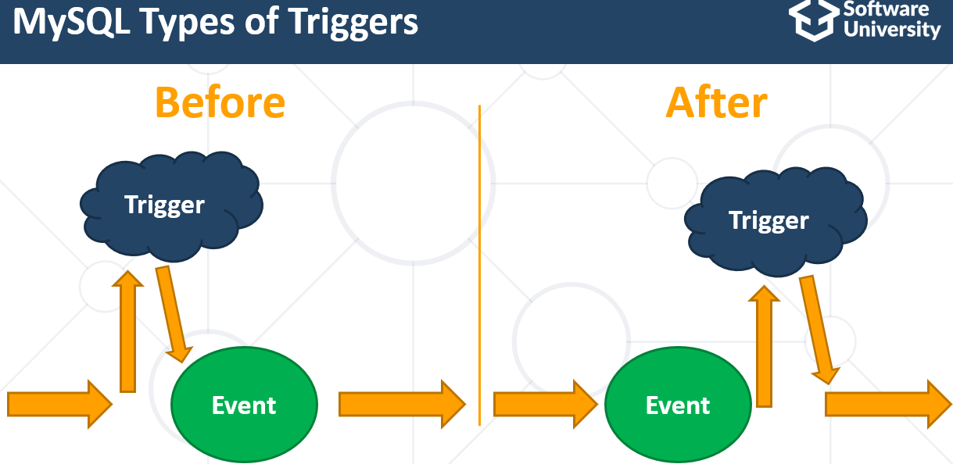

There are three different events that can be applied within a trigger:

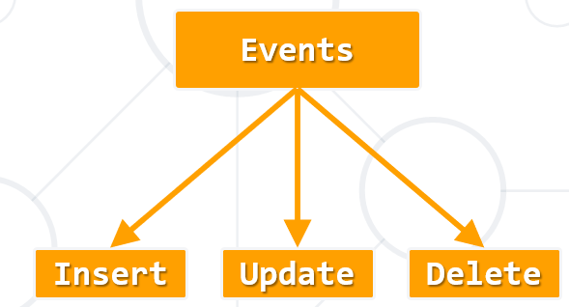

The OLD and NEW keywords allow you to access columns before/after trigger action

OLD – **before trigger action – използва се при AFTER events**

NEW – **after trigger action – използва се при BEFORE events**

#### After Delete

**CREATE TABLE** deleted_employees(

employee_id INT PRIMARY KEY AUTO_INCREMENT,

first_name VARCHAR(20),

last_name VARCHAR(20),

middle_name VARCHAR(20),

job_title VARCHAR(50),

department_id INT,

salary DOUBLE

);

**CREATE TRIGGER** tr_deleted_employees

**AFTER DELETE**

**ON** employees

**FOR EACH ROW**

**INSERT INTO** **deleted_employees** (first_name,last_name,middle_name,job_title,department_id,salary)

**VALUES**(OLD.first_name, OLD.last_name, OLD.middle_name, OLD.job_title, OLD.department_id, OLD.salary);

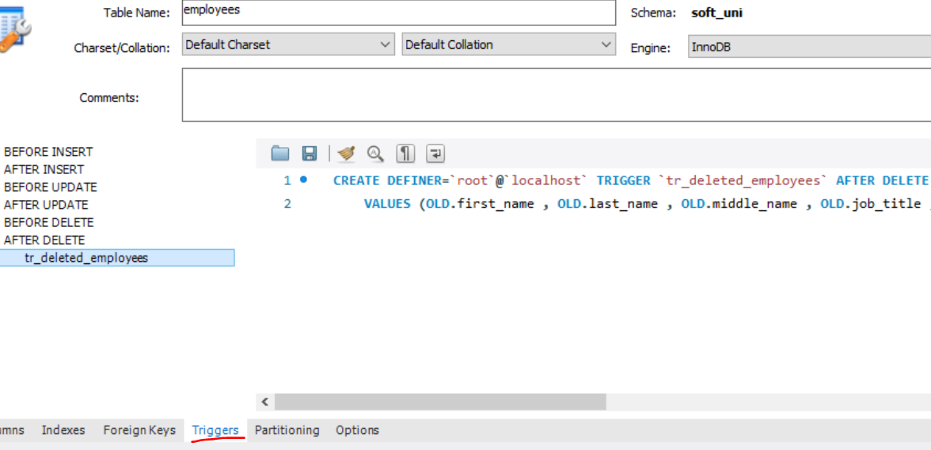

#### Before Insert

CREATE TRIGGER trigger_employee

**BEFORE INSERT**

ON `employees`

FOR EACH ROW

BEGIN

END;

#### After Update

**CREATE** DEFINER = CURRENT_USER **TRIGGER** `employee_AFTER_UPDATE` **AFTER UPDATE**

**ON** `employees`

**FOR EACH ROW**

INSERT INTO addresses_archive (old_salary, new_salary) VALUES (**OLD.salary**, **NEW.salary**)

INSERT INTO LOGS addresses_archive (old_salary, new_salary) VALUES (**OLD.salary**, **NEW.salary**)

За по-лесно, може да ползваме и този прозорец

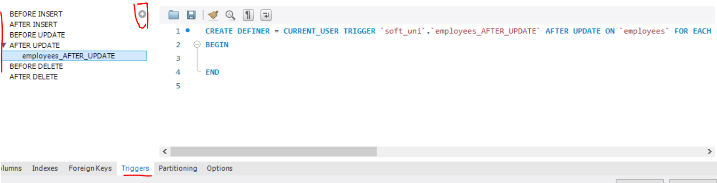

#15. Log Accounts Trigger

CREATE TABLE `logs`(

`log_id` INT PRIMARY KEY AUTO_INCREMENT,

`account_id` INT NULL,

`old_sum` DECIMAL(19, 4) NOT NULL,

`new_sum` DECIMAL(19, 4) NOT NULL);

DELIMITER $$

**CREATE TRIGGER** `tr_balance_updated`

**AFTER UPDATE ON** `accounts`

**FOR EACH ROW**

**BEGIN -** пишем го след FOR EACH ROW

**IF OLD**.`balance` != **NEW**.`balance` **THEN**

**INSERT INTO** `logs`(`account_id`, `old_sum`, `new_sum`) **VALUES** (OLD.`id`, OLD.`balance`, NEW.`balance`);

**END IF;**

**END;**$$

**DROP TRIGGER** `tr_balance_updated`;

Тази проверка е излишна, освен разбира се ако има промяна не в баланса, а в други данни

#IF OLD.`balance` != NEW.`balance` THEN

#END IF;

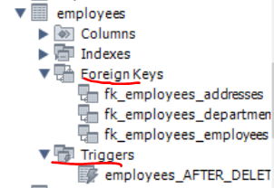

CREATE TABLE IF NOT EXISTS `accounts` (

**`id`** int(11) NOT NULL,

`account_holder_id` int(11) NOT NULL,

**`balance`** decimal(19,4) DEFAULT '0.0000',

PRIMARY KEY (`id`),

CREATE TABLE logs(

**log_id** INT PRIMARY KEY AUTO_INCREMENT,

**account_id** INT,

**old_sum** DECIMAL(19, 4),

**new_sum** DECIMAL(19, 4)

);

**CREATE** DEFINER=`root`@`localhost` **TRIGGER** `accounts_AFTER_UPDATE`

**AFTER UPDATE**

**ON** `accounts` **FOR EACH ROW**

INSERT INTO **`logs`** (`account_id`, `old_sum`, `new_sum`) - **вкарай в новата таблица `logs`**

VALUES (OLD.`id`, OLD.`balance`, NEW.`balance`); - **вземи данни от таблица `accounts` където правим промени**

## 9. Глобални настройки / стойности

**SELECT** DATABASE(); *--Returns the name of the current database***SELECT** *USER()*; *--Returns the current MySQL user and host***SELECT** VERSION(); *--Returns the version of MySQL you are using*

### За смяна на root паролата

**ALTER USER** 'root'@'localhost' IDENTIFIED BY '';

flush privileges;

### За проверка свързана с външни ключове

#Игнорирай външните ключове, за да можем да си трием спокойно :)

**SET** FOREIGN_KEY_CHECKS = 0;

#Имай в предвид външните ключове

**SET** FOREIGN_KEY_CHECKS = 1;

### Общи

**SET GLOBAL** log_bin_trust_function_creators = 1; //да се доверявам на функциите ако аз съм ги създал

**SET** SQL_SAFE_UPDATES = 0; //да махнем safe updates

**SELECT** @@sql_mode;

**SET** sql_mode = 'ONLY_FULL_GROUP_BY'; **- активен този mode**

**SET** sql_mode = '';- премахни only full group by – да го използваме в Judge, но няма ефект ☹

**Има промяна в Judge – Judge работи вече само в mode 'ONLY_FULL_GROUP_BY'**

**Когато групираме по PRIMARY KEY, няма проблеми обаче!!!**

**Друг вариант е да използваме вложени заявки и да не използваме GROUP BY!!!**

**GROUP_CONCAT**

**ANY_VALUE**(muhaha) **AS** `bla_bla_bla`;

# III. Installing PostgreSQL

<https://www.postgresqltutorial.com/postgresql-getting-started/install-postgresql/>

## Creating new database

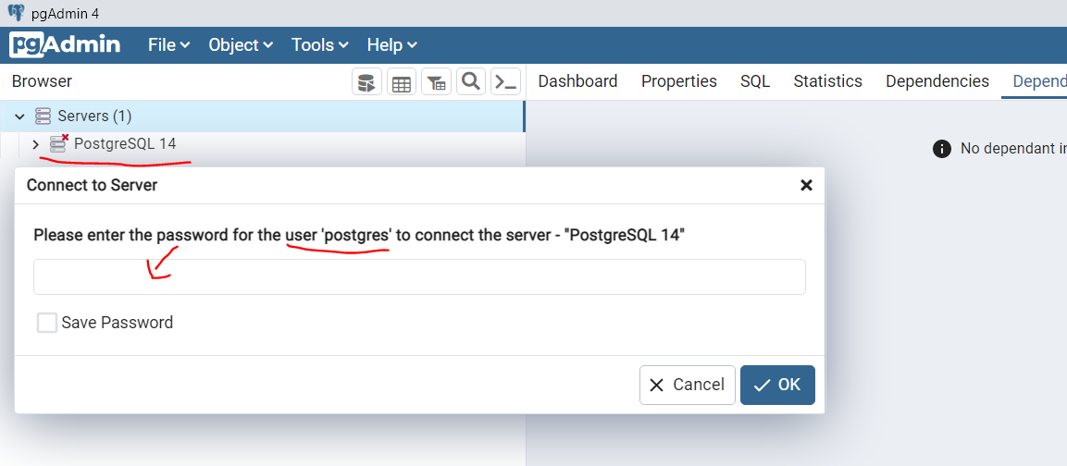

Мога да си създавам new database на server PostgreSQL 14 (user: postgres   pass: 1), и да ползвам schema public винаги, и така няма проблем.

quarkus.datasource.db-kind=postgresql

quarkus.hibernate-orm.database.generation=update

quarkus.datasource.username = postgres

quarkus.datasource.password = 1

quarkus.datasource.jdbc.url=jdbc:postgresql://localhost:5432/pharmacydemo

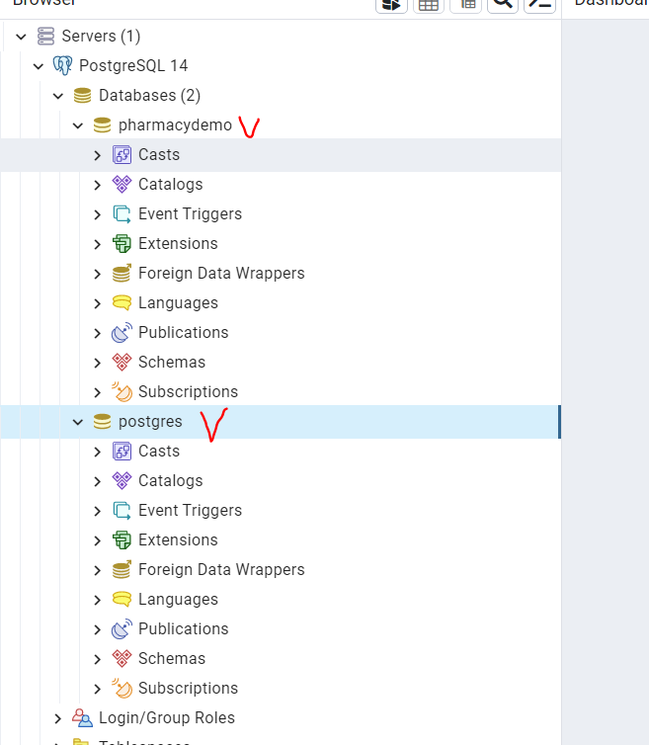

## Stopping postgres server on Windows

1. Open Run Window by Winkey + R.
2. Type     **services.msc**
3. Search Postgres service based on version installed.
4. Click stop, start or restart the service option.

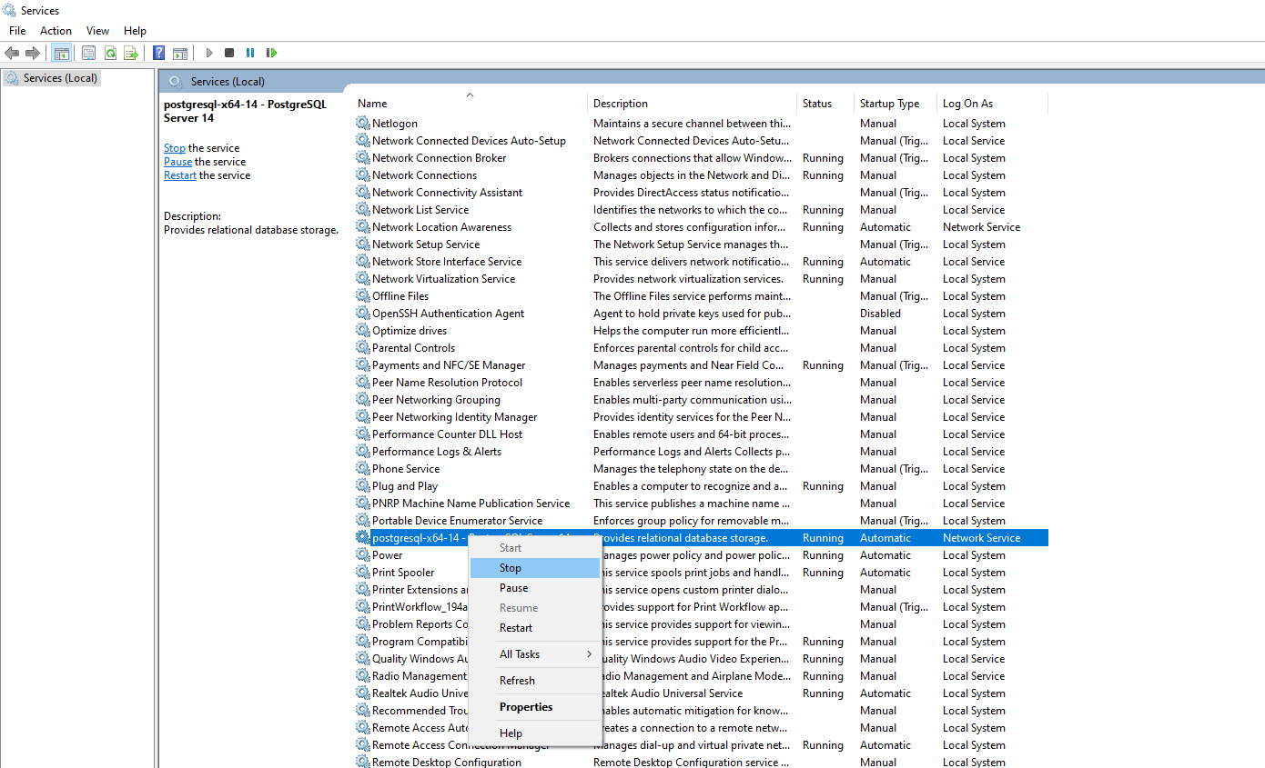

# IV. PostgreSQL vs MySQL

В общи линии, всичко каквото има MySQL, го има и в PostgreSQL.

Но не всичко, което е в PostgreSQL го има в MySQL.

## Връщане на резултата от заявката

При MySQL ще се наложи да направим втора заявка за гетване на обновения запис.

insert into USERS(username, email, password)

values('spas2', 'spas2@gmail.com', 'password')

**returning *;**

## Nested SELECT subqueries

SELECT statements can be nested in the where clause.

* Correlated and Uncorrelated subqueries
* Note: If a subquery and a JOIN can accomplish the same task, it is often **more efficient to use a JOIN**! - понеже базата прави оптимизации при JOIN, а не прави оптимизации при  **nested subqueries**
* **When two or more different tables, subquery possible only in PostgreSQL!**

### Subquery in the SELECT clause

SELECT firstName, lastName,

(SELECT departmentName FROM Department WHERE Department.departmentId = Employees.departmentId) AS departmentName

FROM Employees;

### Subquery in the FROM clause

SELECT *AVG*(emloyeeCount)

FROM (

   SELECT *COUNT*(*\**) AS employeeCount

   FROM Employees

   GROUP BY departmentId

) AS subQuery;

### Subquery in the WHERE clause

Correlated subquery

SELECT E.firstName, E.lastName, E.departmentId

FROM Employees E

WHERE *EXISTS* ( using the EXISTS function

   SELECT *

   FROM Department D

   WHERE D.departmentId = E.departmentId AND D.departmentName = 'Department 1'

);

The argument of EXISTS is an arbitrary SELECT statement, or subquery. The subquery is evaluated to determine whether it returns any rows. If it returns at least one row, the result of EXISTS is "true";

## UPDATE JOIN

**Updating data - using data from other tables**

PostgreSQL can use also subqueries:

UPDATE table_name

SET column1 = (SELECT column2 from other_table WHERE condition)

WHERE condition;

MySQL cannot use subqueries, but join:

UPDATE table_name

JOIN other_table

ON table_name.column1 = other_table.column2

SET table_name.column1 = new_value

WHERE condition;

## DELETE JOIN

Deleting data using Joins

PostgreSQL can use also subqueries:

DELETE FROM Emloyees

WHERE id IN (SELECT id FROM Departments WHERE condition);

MySQL cannot use subqueries, but join:

DELETE Emloyees, Departments FROM Emloyees

JOIN Departments ON Employees.id = Departments.id

WHERE condition;

DELETE empl FROM Emloyees AS empl

JOIN Departments ON empl.id = Departments.id

WHERE condition;

## ON CONFLICT (like a trigger)

PostgreSQL

explain INSERT INTO Employees(id, firstname, lastname, departmentid, dateofbirth, employeecardid, status)

VALUES(34, 'Jo', 'Doe', 1111, '1990-01-01', 1234, 'Available')

ON CONFLICT (id) DO UPDATE SET

status='Blocked',

timestamp=now();

MySQL

explain INSERT INTO Employees(id, firstname, lastname, departmentid, dateofbirth, employeecardid, status)

VALUES(34, 'Jo', 'Doe', 1111, '1990-01-01', 1234, 'Available')

ON DUPLICATE KEY UPDATE

status='Blocked',

timestamp=now();

A row to be inserted would cause a duplicate value in a UNIQUE index or PRIMARY KEY

//An [INSERT ... ON DUPLICATE KEY UPDATE](https://dev.mysql.com/doc/refman/8.0/en/insert-on-duplicate.html) statement against a table having more than one unique or primary key is also marked as unsafe. (Bug #11765650, Bug #58637)

## Numbers in PostgreSQL vs numbers in Java

**32 bit signed integer - positive and negative: +(2^31-1) and -(2^31):**

В java това е int

В PostgreSQL това е int4

**64 bit signed integer** - **positive and negative: +(2^63-1) and -(2^63):**

В java това е long

В PostgreSQL това е int8

**BigDecimal**

В java - BigDecimal

В PostgreSQL - numeric или decimal

|  |  |  |  |
| --- | --- | --- | --- |
| **Name** | **Storage Size** | **Description** | **Range** |
| decimal | variable | user-specified precision, exact | up to 131072 digits before the decimal point; up to 16383 digits after the decimal point |
| numeric | variable | user-specified precision, exact | up to 131072 digits before the decimal point; up to 16383 digits after the decimal point |

В postgresql няма разлика между decimal(19, 2) и numeric(19 ,2), но в други SQL има разлика.

numeric(19,2)

## nextval()

nextval() взема следващ номер в поредицата на postgresql

create sequence hibernate_sequence start 1 increment 1;

create table if not exists loyalty_level (

                                    id int8 not null,

                                    level int4 not null,

                                    points int8 not null,

                                    primary key (id)

);

insert into loyalty_level(id, level, points)

values

(*nextval*('hibernate_sequence'), 1, 0),

(*nextval*('hibernate_sequence'), 2, 20),

(*nextval*('hibernate_sequence'), 3, 35),

(*nextval*('hibernate_sequence'), 4, 55),

## temporary sequence

-- First you create temporary sequence. It will get dropped when the session is ended.

**create temporary sequence** s_milestone;

-- Next you assign the milestones with a simple update query

update loyalty_level

set milestone = nextval('s_milestone')

where level in (1,6,11,16,21)

order by level asc;

## Procedure

**POSTGRESQL syntaxis**

alter table if exists loyalty_level

   add column milestone int4 not null default 0;

DO

$$

   DECLARE

       next_milestone int4;

       current_level int4;

       level_config_size int4;

   BEGIN

       current_level := (SELECT ll.level FROM loyalty_level AS ll ORDER BY ll.level ASC LIMIT 1);*--BO can update levels by deleting level number 1, so we take the lowest present level number*

next_milestone := 1;

       level_config_size := (SELECT *COUNT*(*\**) FROM loyalty_level);

       WHILE (current_level <= level_config_size) LOOP

           IF current_level IN (1,6,11,16,21)

           THEN

*--levels between milestone levels also have milestones*

update loyalty_level

               set milestone = next_milestone

               where level >= current_level;

               next_milestone := next_milestone + 1;*--next milestone always increase with 1*

END IF;

           current_level := current_level + 1;*--levels always increase with 1*

END LOOP;

   END

$$;

## Using cast()

In PostgreSQL we can use cast

SELECT **cast(**p.id **as text)** FROM Profile p WHERE p.status IN (?1)

## COALESCE function syntax

PostgreSQL

The COALESCE function accepts an unlimited number of arguments. It returns the first argument that is not null. If all arguments are null, the COALESCE function will return null.

update wallet w

set lifetime_deposit = coalesce((select sum(d.amount)

                    from deposit d

                    where d.wallet_id = w.id

                    and d.balance_change_reason in ('PLAYER_DEPOSIT', 'PLATFORM_MIGRATION')

                    and d.status = 'ACCEPTED'), **0**);

## SELECT in WITH clause - only in PostgreSQL

Common Table Expression (CTE) subquery

The basic value of SELECT in WITH is to break down complicated queries into simpler parts. An example is:

WITH **regional_sales** AS (

   SELECT region, *SUM*(amount) AS total_sales

   FROM orders

   GROUP BY region

),

**top_regions** AS (

   SELECT region

   FROM **regional_sales**

   WHERE total_sales > (SELECT *SUM*(total_sales)/10 FROM regional_sales)

)

SELECT region,

      product,

*SUM*(quantity) AS product_units,

*SUM*(amount) AS product_sales

FROM orders

WHERE region IN (SELECT region FROM **top_regions**)

GROUP BY region, product;

which displays per-product sales totals in only the top sales regions. The WITH clause defines two auxiliary statements named regional_sales and top_regions, where the output of regional_sales is used in top_regions and the output of top_regions is used in the primary SELECT query. This example could have been written without WITH, but we'd have needed two levels of nested sub-SELECTs. It's a bit easier to follow this way.

## Common functions

### String functions:

MySQL: CONCAT(), SUBSTRING(), LENGTH(), UPPER(), LOWER(), TRIM(), REPLACE()

PostgreSQL: CONCAT(), SUBSTRING(), LENGTH(), UPPER(), LOWER(), TRIM(), REPLACE()

### Mathematical functions:

MySQL: ABS(), CEIL(), FLOOR(), ROUND(), SQRT(), LOG(), EPX(), POW(), RAND()

PostgreSQL: ABS(), **CEILING()**, FLOOR(), ROUND(), SQRT(), **LN()**, EXP(), **POWER()**, **RANDOM()**

### Date and time functions:

MySQL: NOW(), CURDATE(), CURTIME(), DATE(), TIME(), YEAR(), MONTH(), DAY(), HOUR(), MINUTE(), SECOND(),

EXTRACT(YEAR from date), EXTRACT(MONTH from date), EXTRACT(DAY from date),

PostgreSQL: NOW(), CURRENT_DATE, CURRENT_TIME, DATE(), TIME(),

EXTRACT(YEAR from date), EXTRACT(MONTH from date), EXTRACT(DAY from date),

EXTRACT(HOUR FROM time), EXTRACT(MINUTE FROM time), EXTRACT(SECOND FROM time)

### Conditional expressions:

MySQL: IF(), CASE

PostgreSQL: CASE, COALESCE(), NULLIF()

### Regular expressions:

MySQL: REGEXP, NOT REGEXP

PostgreSQL:

**~**

**!~**

**~\***

**!~\***

**SELECT firstname FROM** employees **WHERE firstname** ~ **'a'**; *--Returns names containing 'a'***SELECT firstname FROM** employees **WHERE firstname** !~ **'a'**; *--Returns names not containing 'a'*

## Array to String

In PostgreSQL

**SELECT** ARRAY_TO_STRING(ARRAY[1, 2, 3, 4], **','**);

**SELECT** STRING_TO_ARRAY(**'1,2,3,4'**, **','**);  
**SELECT** ARRAY_LENGTH(ARRAY[1, 2, 3, 4], 1);

## Window aggregation

Both for MySQL and PostgreSQL

**select FirstName**, **Salary**,  
*avg*(**Salary**) **over** (**PARTITION by** DepartmentId **order by** DateOfBirth)  
**from** Employees;

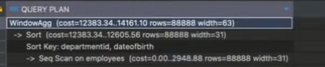

## Глобални команди

**SELECT** CURRENT_DATABASE(); *--Returns the name of the current database***SELECT** *CURRENT_USER*; *--Returns the name of the current user***SELECT** VERSION(); *--Returns the version of PostgreSQL you are using*

**SYSTEM** information functions;

# V. NoSQL

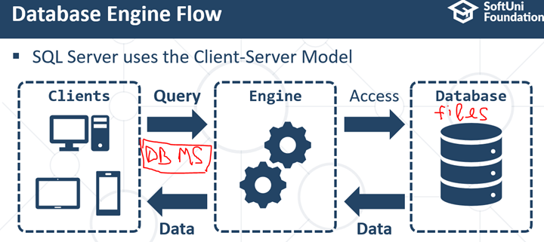

## 1. General info

* NoSQL - stands for “**Not only SQL**”, non-tabular databases
* First used in 1998
* Tackle (да се пребори с) problems of performance, volume and variety of data
* Handling of unstructured or semi-structured data
* Scale horizontally - добавяме все повече и повече load-ове, партитишъни, клъстъри и сървъри (вместо повече процесор и рам памет - вертикално скалиране)
* Flexibility, scalability and speed.

## 2. NoSQL vs Relational Model

Similarities:

* Both are used for storing and managing data
* Both support CRUD (Create, Read, Update, Delete) operations
* Both provide mechanisms for ensuring data consistency and integrity

Differences:

* **Schema:** Relational databases have a fixed schema while NoSQL databases are usually schema-less.
* **Scalability**: Relational databases traditionally scale vertically while NoSQL databases are designed to scale horizontally
* **Consistency**: Relational databases provide strong consistency (ACID [Atomicity-Consistency-Isolation-Durability] properties) while NoSQL databases often offer eventual consistency
* **Data model**: Relational databases use tables with rows and columns for data storage while NoSQL databases use a variety of data models: including key-value, document, columnar and graph.

**NoSQL Databases (Non-Relational Databases)**

A NoSQL database, has dynamic schema for unstructured data

-        има задължителни полета, но има и полета, които може да не са попълнени

-        Може да се променя формата на данните, които се съхраняват чрез Dynamic data – това e плюс за бизнес, който често сменя нещата в базата си от данни поради характера на бизнеса си.

<https://www.xplenty.com/blog/the-sql-vs-nosql-difference/>

SQL могат и хоризонтално, но е по-трудно

NoSQL – в 3 през нощта 300 000 души се записват и искат да се логнат. Тогава се активират хоризонтални shardins/клъстери/паралелни сървъри и те успяват да запишат всички 300 000 души,  които се регистрират 2 3 през нощта.

## 3. Fundamental concepts in NoSQL

### CAP Theorem

* We can guarantee two out of these three properties:
  + **C**onsistency
  + **A**vailability
  + **P**artition Tolerance
* **Consistency**: every read gets the most recent write or error
* **Availability**: every request receives a response without guaranteeing it contains most recent write (последно записаната информация) - т.е. ако даден клъстър/сървър падне, то ще вземем информацията от друг сървър и потребителят няма да разбере, че получава неактуални стари данни
* **Partition Tolerance**: system can continue operation even if there are communication breakdown between nodes

### CAP Theorem - Impact

* If a system chooses consistency and availability (CA), then it can’t tolerate network partitions
* If a system that opts for consistency and partition tolerance (CP), then it may not always be available
* If a system chooses availability and partition tolerance (AP), then it may occasionally serve stale or inconsistent old data
* Network partitions are almost inevitable in distributed systems (срив в комуникацията е напълно възможно да се случи) and **most databases prioritize partition tolerance** plus the expense of availability **or** consistency

### Consistency

Уточнение какво имаме в предвид под сървър. Сървърно приложение, което вдига инстанция на база данни. Т.е. Когато си пуснем локално база данни е една инстанция. Но на практика могат да бъдат много инстанции на едно и също приложение. Начина по който си комуникират е въпрос на архитектура. Примерно в Кубернетис може да имаме няколко клъстъра за един и същи микросървис, по-точно говорейки за бази данни няколко клъстъра/аплиакции за една и съща база данни.

* **Data is the same across all nodes at any given time.**
  + A write operation on one Node will be reflected by reading data from any node - като запишем една информация, то от който и да е Reader Replica Node трябва да достъпим същите новозаписани данни

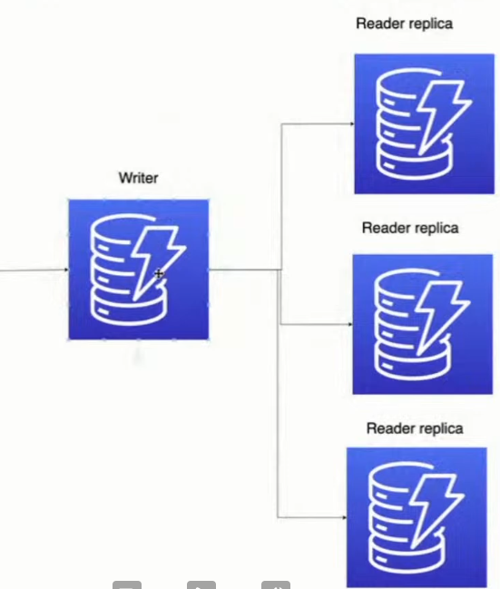

* **Strong consistency**
  + Write operation is not considered complete until the changes have been propagated to all nodes - т.е. докато не се запише записа **в/на** всяка една reader replica, то не го считаме за complete. Т.е. aко някоя reader replica е долу, може да чакаме доста или може и изобщо да не се финализира/осъществи записа
  + Higher latency and less availability
* **Eventual consistency**
  + Write operation is considered complete once it’s written to any node - или в нашия пример когато информацията се запише в основния Writer replica, то не ни интересува дали веднага се е пропагирала към останалите Reader replica.
  + Changes are propagated to other nodes eventually/в последствие
  + Stale/old data read possible

### Partitioning

* Breaking up large datasets into smaller ones `partitions` or also called sharding
* Each partition is stored in a separate database, node or server
* Better distribution of read/write loads and improved scalability and performance

Комуникацията между всяка реплика/партитишън най-често се осъществява чрез хеш кода за бързина.

#### Types of Partitioning

**Horizontal (Sharding)**

* Data is split **into rows** and each set of rows is stored in different partition - but **same number of columns**!!
* Each partition forms a separate table with same schema and number of columns

**Vertical**

* Dividing a table into smaller tables with subset of data
* Each partition contains a **different set of columns, and same number of rows possible**
* Used to split rarely accessed or wide columns

#### Partitioning strategies

**Range partitioning:**

* Created based on a certain range of the partition key (PK). E.g. Employees with IDs from 1 to 10 000 in one partition and from 10 001 to 20 000 in another

**Hash partitioning:**

* Applying a hash function to some attribute which results in a partition number. Ensures a **more balanced distribution of data**.

**List partitioning**:

* DBA explicitly maps each partition to a list of discrete values of the partition key.

#### Partitioning - Challenges

* Data distribution to be balanced, otherwise we get what is called `**hot partitions**`, т.е. всички данни отиват в един партитишън, което не е добре - няма да бъде възможно да се възползваме от перформънса. Например ако primary key e first_name и има много Антоновци да речем.
* Data locality is crucial and operations involving multiple partitions can be slow
* Partitioning adds complexity and makes Database management and tuning harder.

### Schema-less Design

* Traditional relational databases need to have the schema defined in advance and adhered (придържам / спазвам) strictly
* NoSQL provide Shema-less or schema-flexible models
* **Structure of data is not predefined -** т.е. можем да работим без схема в самото начало/ не е необходимо и да указваме тип на данните/на колоните
* **We can change the structure of the data on the fly**

**Benefits:**

* **Flexibility:** Schema-less models are highly flexible, enabling quick adaptation to changes.
* **Speed and Efficiency:** The lack of a rigid(твърда) schema allows for faster development and easier scalability
* **Complex and Hierarchical Data:** Schema-less models can easily store and manage complex, nested, or hierarchical data, which can be difficult to represent in a rigid schema

**Challenges:**

* **Inconsistency:** The flexibility of a schema-less model can lead to data inconsistency if not managed correctly.
* **Lack of Data Integrity:** In a rigid/constant schema, constraints can be applied to ensure data integrity. In a schema-less model, this responsibility often moves to the application layer. Т.е. ще се наложи в нашето Java приложение да си правим ръчни проверки за null value, за тип на колоната, и т.н. тъй като базата може да ни върне нещо което не би следвало да го обработваме. (местим един вид логика/функционалност от базата към въшно приложение)
* **Query Complexity:** Without a consistent schema, querying data can become more complex. Например липсват JOIN в доста от NoSQL езиците, правим по-скъпи операции, и т.н.

**NoSQL databases and implementation of schema-less design:**

* **Document Databases** store data in a flexible, JSON-like format. Each document can have its own unique structure. The schema can be changed in real-time, allowing fields to be added or removed as necessary.
* **Key-Value Stores** have an entirely schema-less design. The value associated with a key can be of any type, and there’s no structure enforced on the values
* **Wide Column Stores** do have a schema, but it is flexible. You can easily add or remove columns in a column family without having to modify the rest of the data
* **Graph Databases** also have flexible schemas. While they do enforce a certain level of structure (with nodes and relationships), the properties of those nodes and relationships can be very flexible

### Scaling

Types of scaling:

* **Vertical Scaling**, or “**scaling up**”, involves increasing the capacity of a single machine. You can do this by adding more powerful CPUs, adding more RAM, increasing disk storage, or improving network capacity
* **Horizontal Scaling**, or “**scaling out**”, involves adding more machines to the system and distributing the load among them. This is the approach typically employed by NoSQL databases.

### Normalization

Нормализацията е контра продуктивна при NoSQL. Данните ни трябва да не са нормализирани.

Можем да имам всички данни в една таблица, и вече примерно в Java или JS приложението да си ги обработваме.

Нормализацията е свързана също така и с JOIN операции, които дори и да ги има в NoSQL то са доста скъпи. T.e. няма JOIN-ове, значи няма и нормализация.

## 4. Types of NoSQL databases

### Key-Value

* Store data as a collection of key-value pairs, similar to a Map
  + Key is unique identifier
  + The value can be anything: number, string, **JSON**, BLOB, etc
* Example: **Redis, DynamoDB** - използват само/главно  key-value
* Use cases:
  + Constant, fast, read/write operations, e.g. caching, session management, shopping carts, etc

**Limitations:**

* No complex querying
* No relationships
* No joining
* Need to handle data structure at application level

Examples:

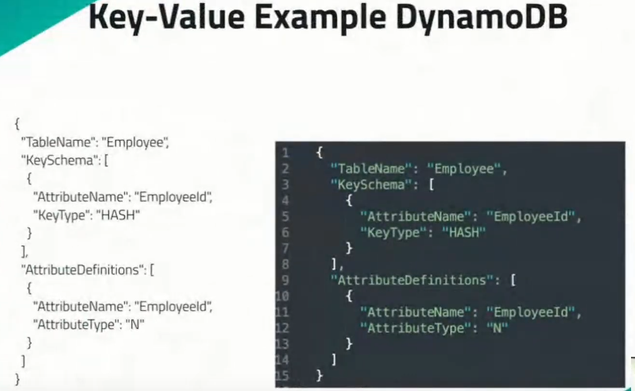

CLI(Command Line Interface) of DynamoDB via AWS



### Document Databases

Subcategory of key-value

Store data in a semi-structured format (often **JSON**)

* Allow for nested data
* Each document has a unique key identifier and a value

Examples: **MongoDB** and CouchDB and **ElasticSearch**(https://www.elastic.co/)

Use cases:

* Content management systems
* Real-time analytics
* IoT

Limitations:

* Comlex transactions
* Data integrity across documents (joins and complex multi-document transactions)

В MongoDB липсва използването на join-ове!

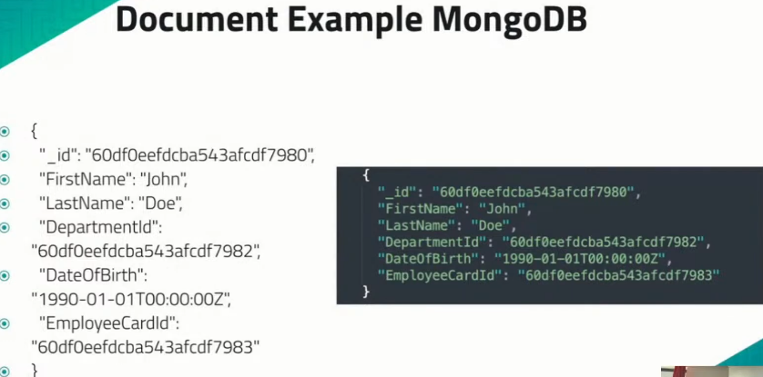

CLI of MongoDB

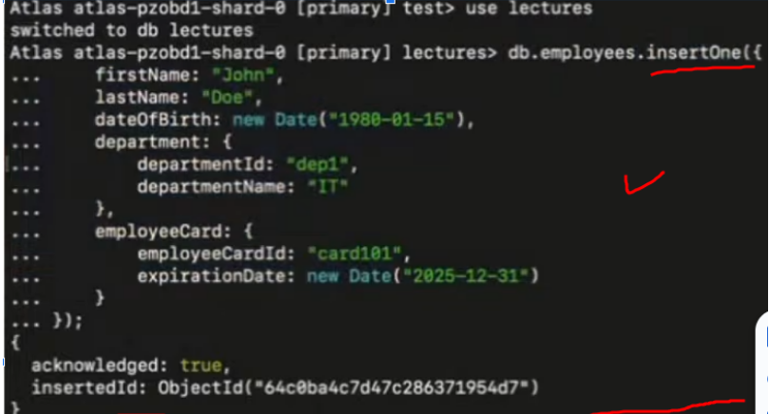

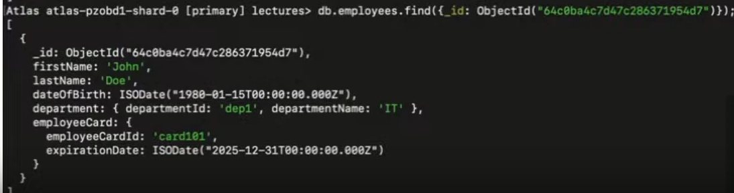

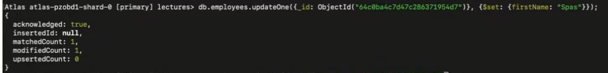



След като сме изтрили един запис, само .find() ни намира всички записи в момента

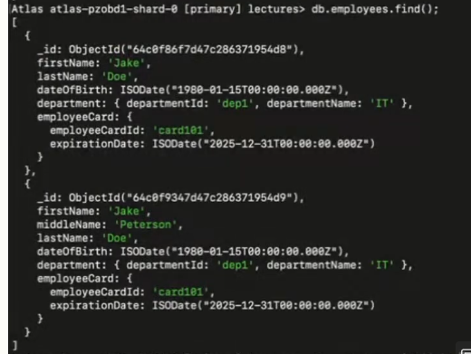

### Wide Column Databases

* Store data in columns rather than stores.
  + Each column family can contain a virtually unlimited number of columns - **колона в колоната**
* Examples: Cassandra and Google’s Bigtable
* Use cases:
  + Querying and analysis of large distributed data sets
* **Limitations**
  + Complex transactions
  + Data integrity across documents (joins or complex multi-document transactions)

### Graph Databases

Build around the concept of Nodes and Edges

* Nodes represent entities
* Edges represent relationships between nodes

Examples: Neo4j and Amazon Neptune

Use cases:

* Social networks
* Recommendation engines

Limitations:

* System with high update rates
* Performance can degrade with data volume

# IX. Other tools for using

Ако искаме, можем да ползваме и XAMPP или MariaDB или Heidi SQL вместо MySQL

